AWS EC2 TASKS
1. Launch an AWS EC2 Instance Using Amazon Linux and Install Apache Using User Data
Objective: This documentation explains how to launch an Amazon EC2 instance using the Amazon Linux AMI and automatically install the Apache web server using a User Data script.
Prerequisites
Before starting, ensure you have:
- An AWS account
- Access to the AWS Management Console
- Basic understanding of AWS EC2
- A key pair for SSH access
Step 1: Login to AWS Console
Screenshot Required
Add screenshot of:
- AWS Management Console Home Page
- Successful login screen
- Selected AWS Region
Example Caption:
AWS Management Console Home Page
- Open the AWS Management Console.
- Navigate to the EC2 Dashboard.
- Select the preferred AWS Region.
EC2 Dashboard:
https://console.aws.amazon.com/ec2/
Step 2: Launch EC2 Instance
Add screenshot of:
- EC2 Dashboard
- Launch Instance button
Example Caption:
EC2 Dashboard – Launch Instance
- In the EC2 Dashboard, click: Launch Instance
Step 3: Configure Instance Details
Add screenshot of:
- EC2 Launch Instance wizard
- Name field
- AMI selection
- Instance type selection
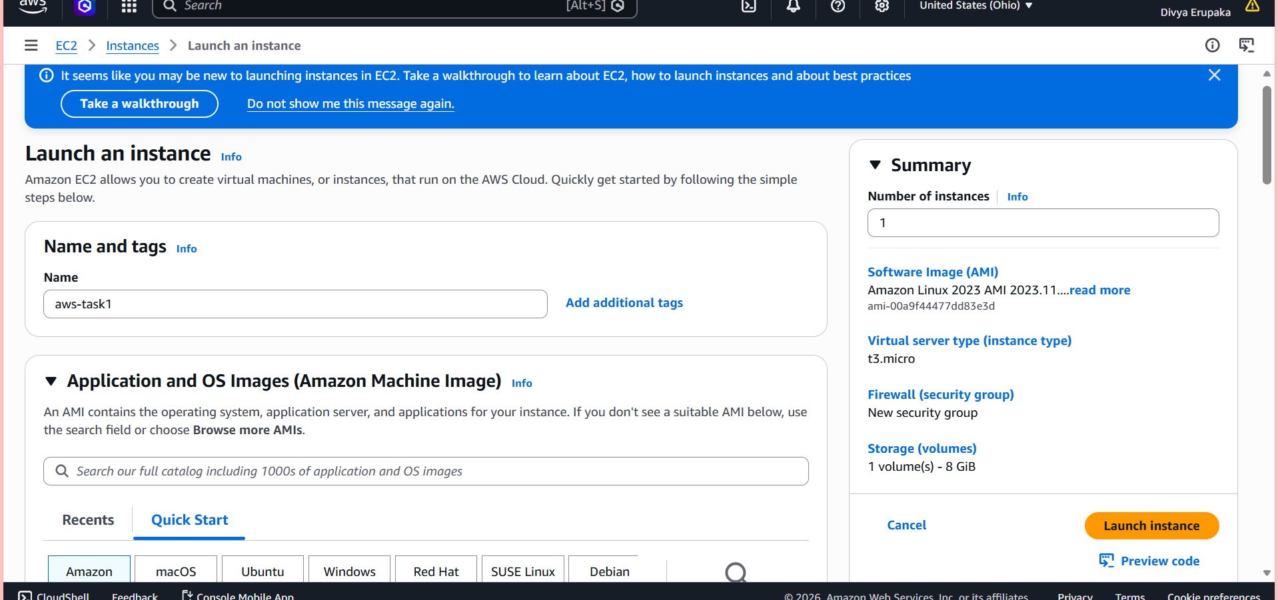
Choose an Amazon Machine Image (AMI)
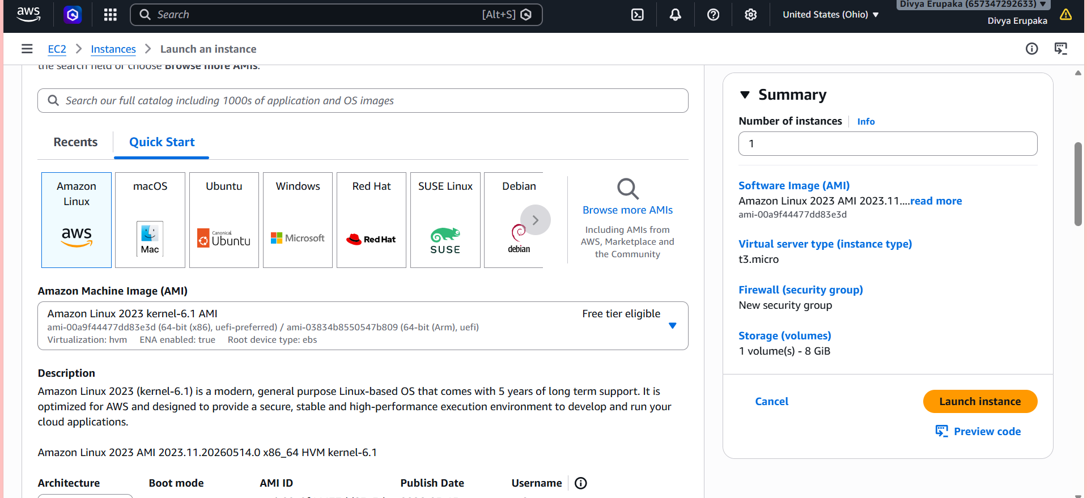
Choose Instance Type and Create or Select a Key Pair
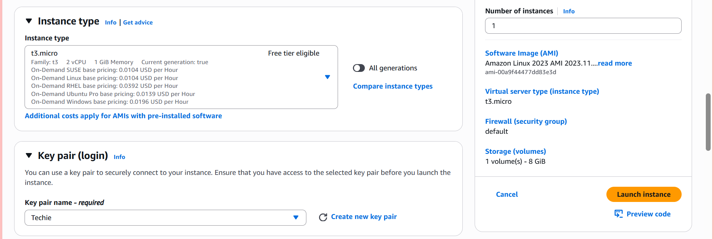
Configure Network Settings
Add screenshot showing:
- Security group configuration
- SSH and HTTP rules
Example Caption:
Security Group Configuration
Allow Required Traffic
Create or select a Security Group.
Add the following inbound rules:
Type | Protocol | Port | Source
SSH | TCP | 22 | My IP
HTTP | TCP | 80 | Anywhere
Explanation:
- Port 22 is used for SSH login.
- Port 80 is used for Apache web traffic.
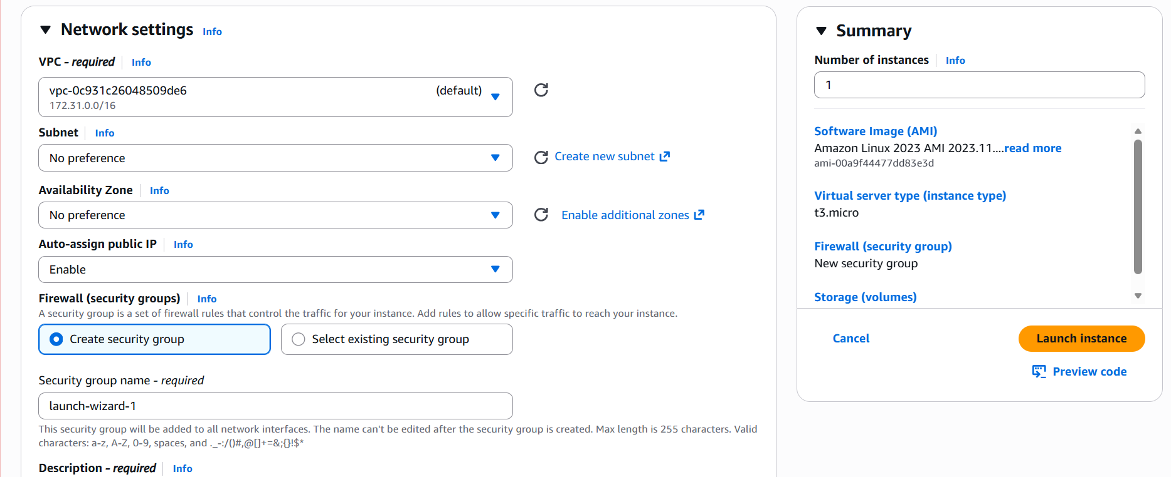
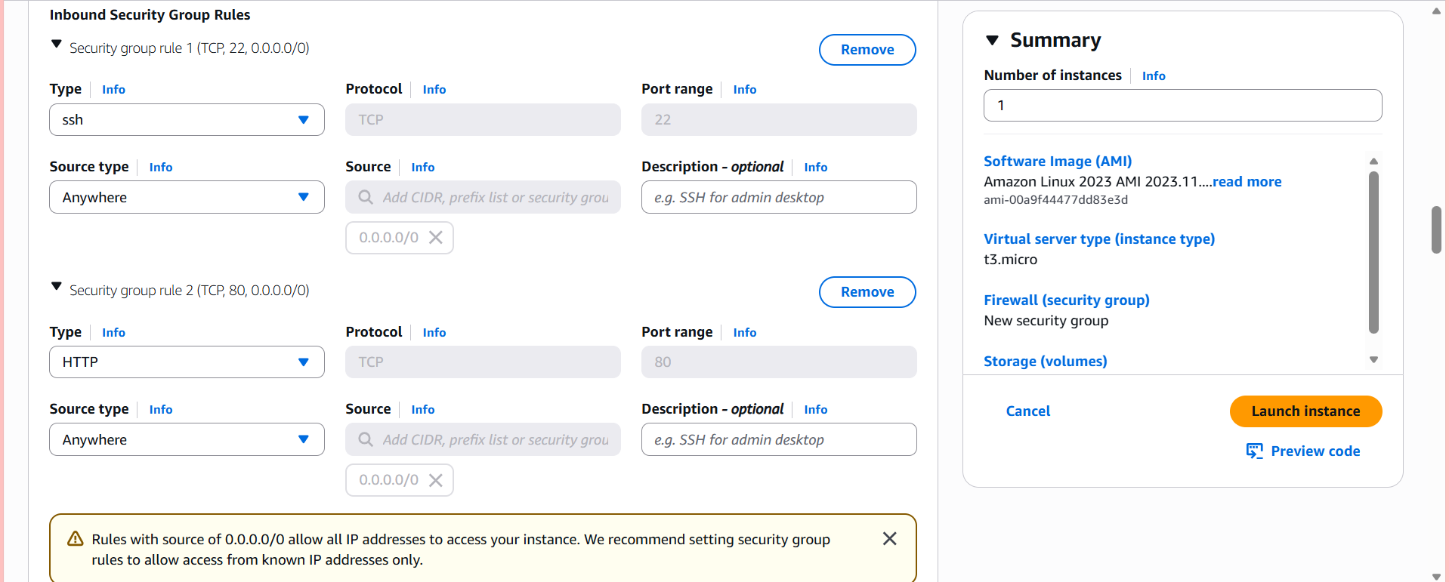
Step 6: Add User Data Script
Add screenshot showing:
- Advanced Details section
- User Data text box
- Apache installation script pasted
Example Caption:
User Data Script Configuration
In the "Advanced Details" section, locate User Data and write the bash script.
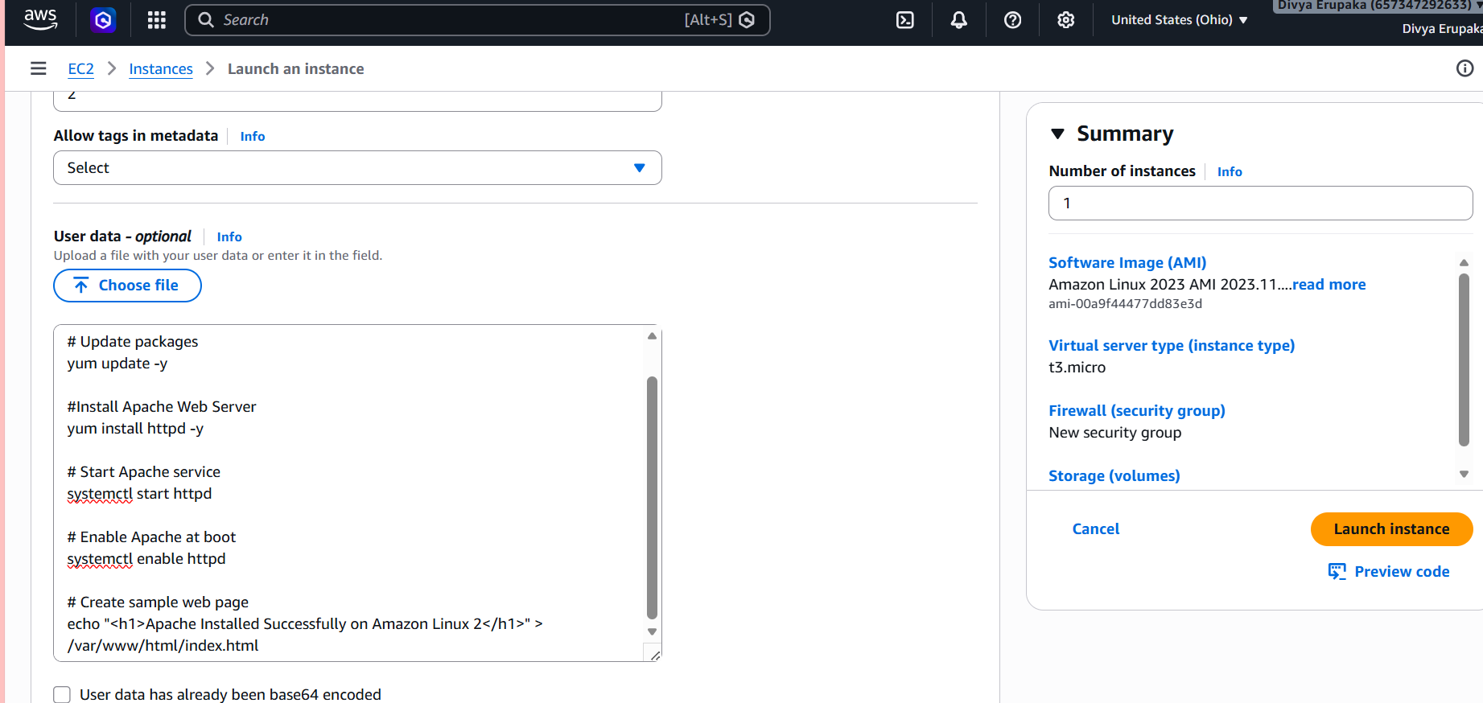
Step 7: Launch Instance
Add a screenshot showing:
- Launch Instance confirmation
- Successful launch message
Click: Launch Instance
AWS will:
- Create the virtual machine
- Attach storage
- Configure networking
- Execute the User Data script automatically during first boot
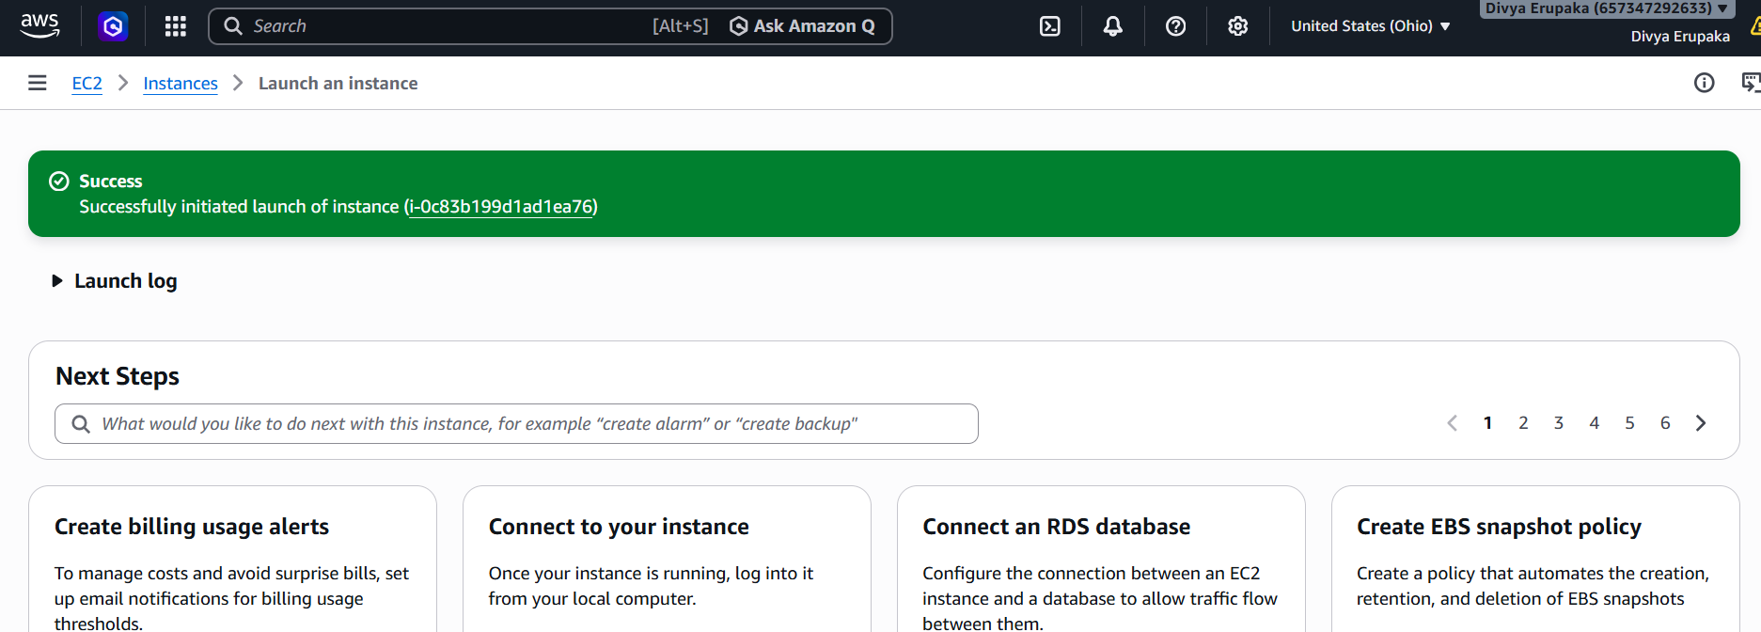
Step 8: Verify EC2 Instance
Add screenshot showing:
- EC2 instance state as Running
- Public IPv4 address visible
Example Caption: Running EC2 Instance Details
- Wait until:
Instance State = Running
- Copy the Public IPv4 Address.
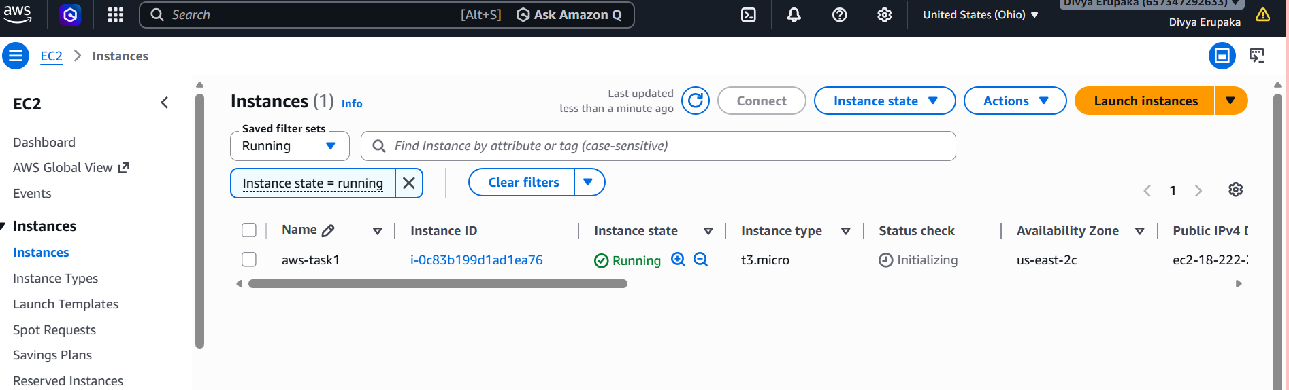
Step 10: Connect to EC2 Using SSH
Add screenshot showing:
- Terminal SSH login
- Successful EC2 connection
Example Caption:
SSH Connection to EC2 Instance
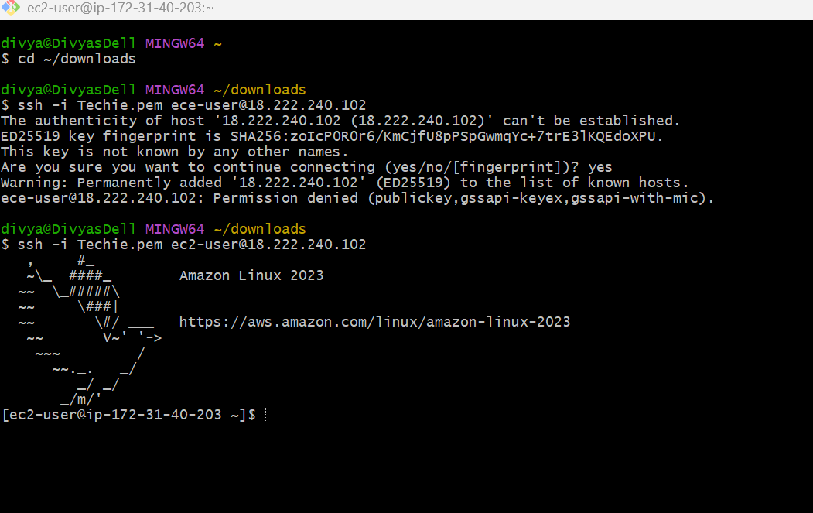
Check if httpd is running or not using systemctl status httpd
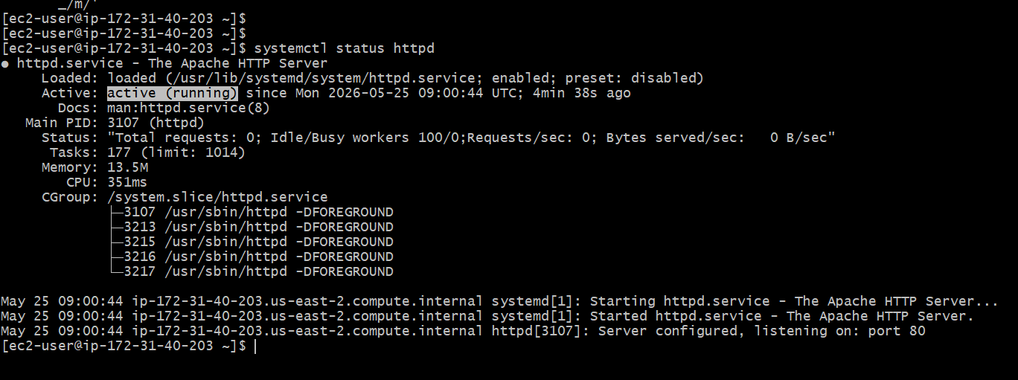
Verify with browser.
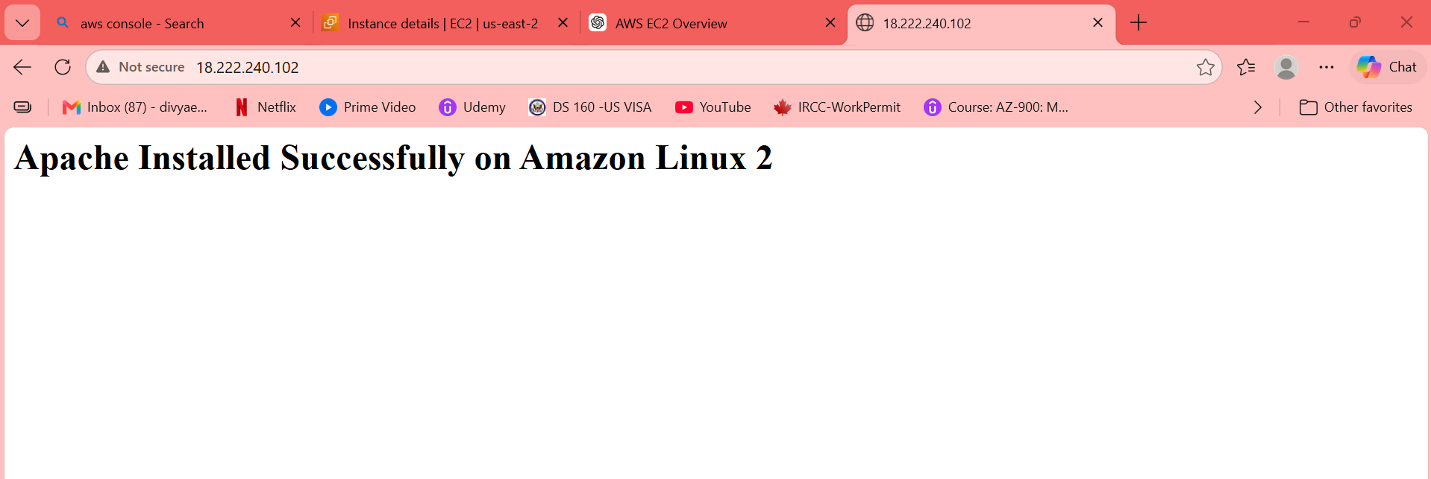
2. Launch one EC2 using Ubuntu image and add a script in user data to install Nginx
Objective
The objective of this project is to:
- Launch an EC2 instance in AWS
- Use Ubuntu as the operating system
- Configure Security Groups
- Add a User Data script
- Automatically install and start Nginx
- Access the web server through a browser
Prerequisites
Before starting, ensure the following:
- AWS account is available
- Access to AWS Management Console
- Internet connection
- Basic understanding of Linux and AWS EC2
Step 1: Login to AWS Console
Procedure
- Open the AWS Management Console.
- Login using AWS credentials.
- Select the preferred AWS Region.
- Navigate to EC2 Dashboard.
Step 2: Launch EC2 Instance
Procedure
- In EC2 Dashboard click: Launch Instance
- Enter the instance name.
Step 3: Select Ubuntu AMI
Procedure
Under Application and OS Images (AMI):
Select:
Ubuntu Server 22.04 LTS
Reason:
- Stable Linux distribution
- Long-term support
- Popular for cloud deployments
Add screenshot showing:
- Ubuntu AMI selected
- AMI details visible
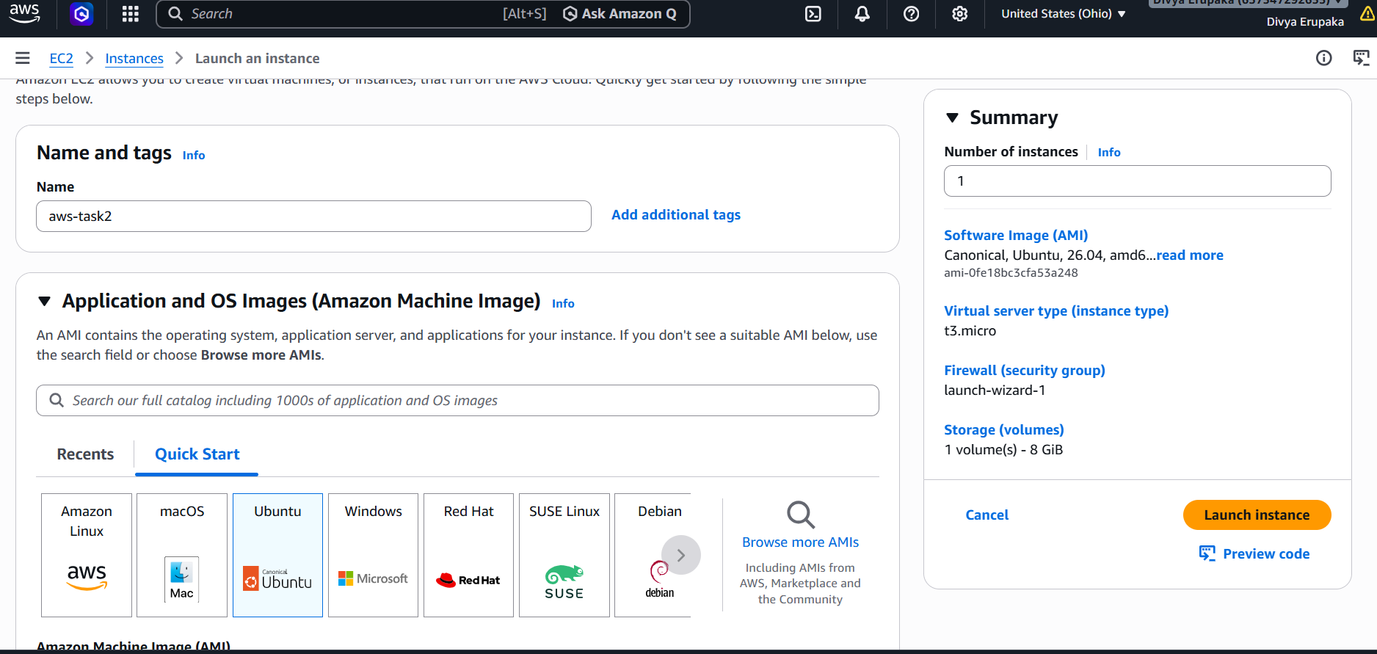
Choose Instance Type and Configure Key Pair
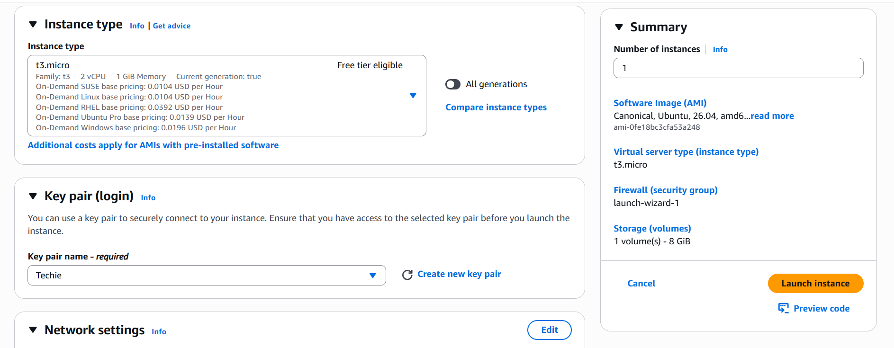
Step 6: Configure Network Settings
Procedure
Create or select a Security Group.
Add the following inbound rules:
Type | Protocol | Port | Source
SSH | TCP | 22 | My IP
HTTP | TCP | 80 | Anywhere
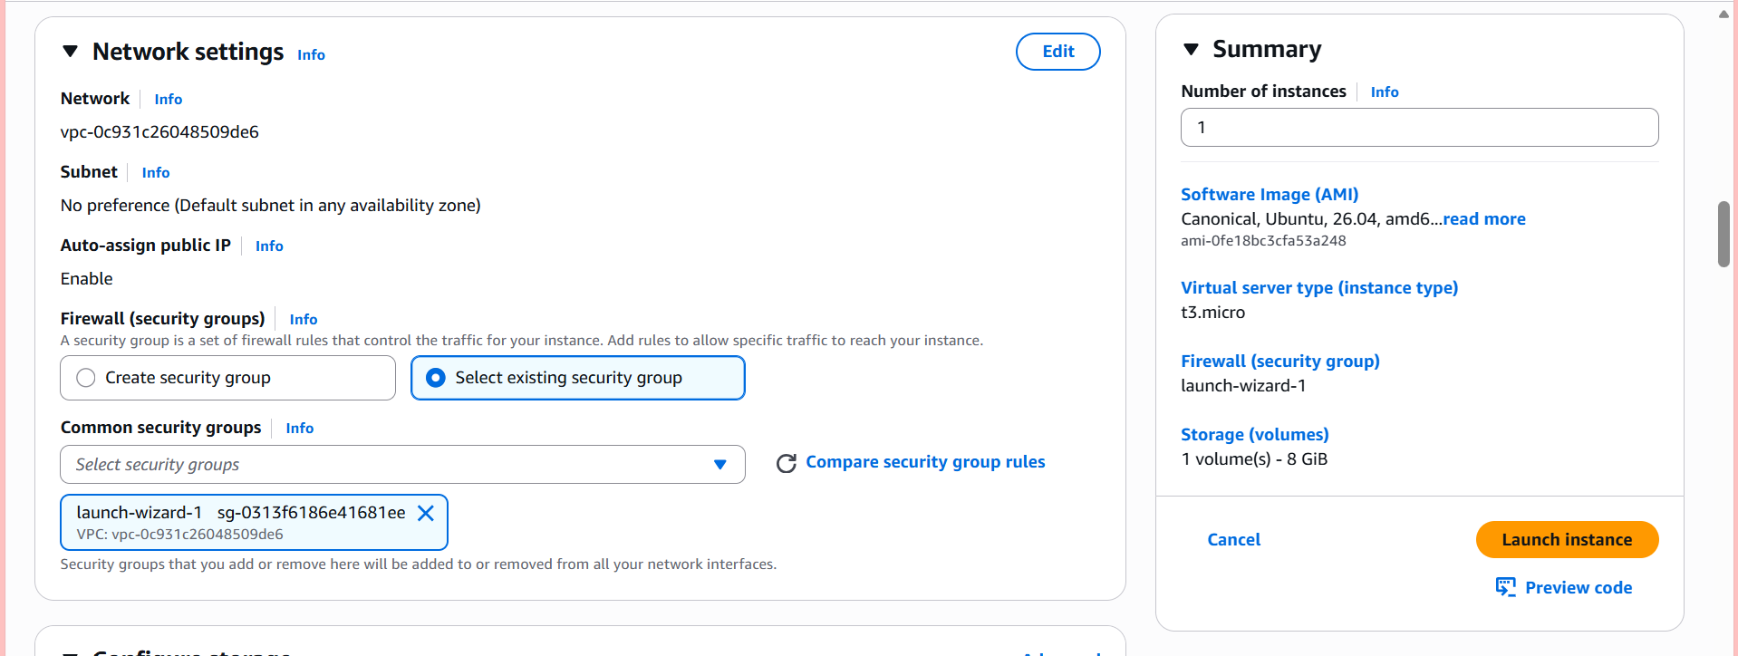
Step 7: Add User Data Script
Procedure
- Expand: Advanced Details
- Locate: User data and write the nginx installation script
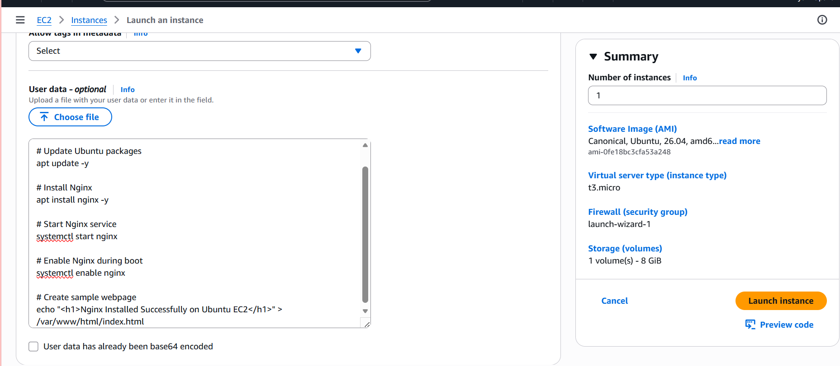
Step 9: Verify EC2 Instance Status
Procedure
- Wait until: Instance State = Running
- Copy the Public IPv4 address.
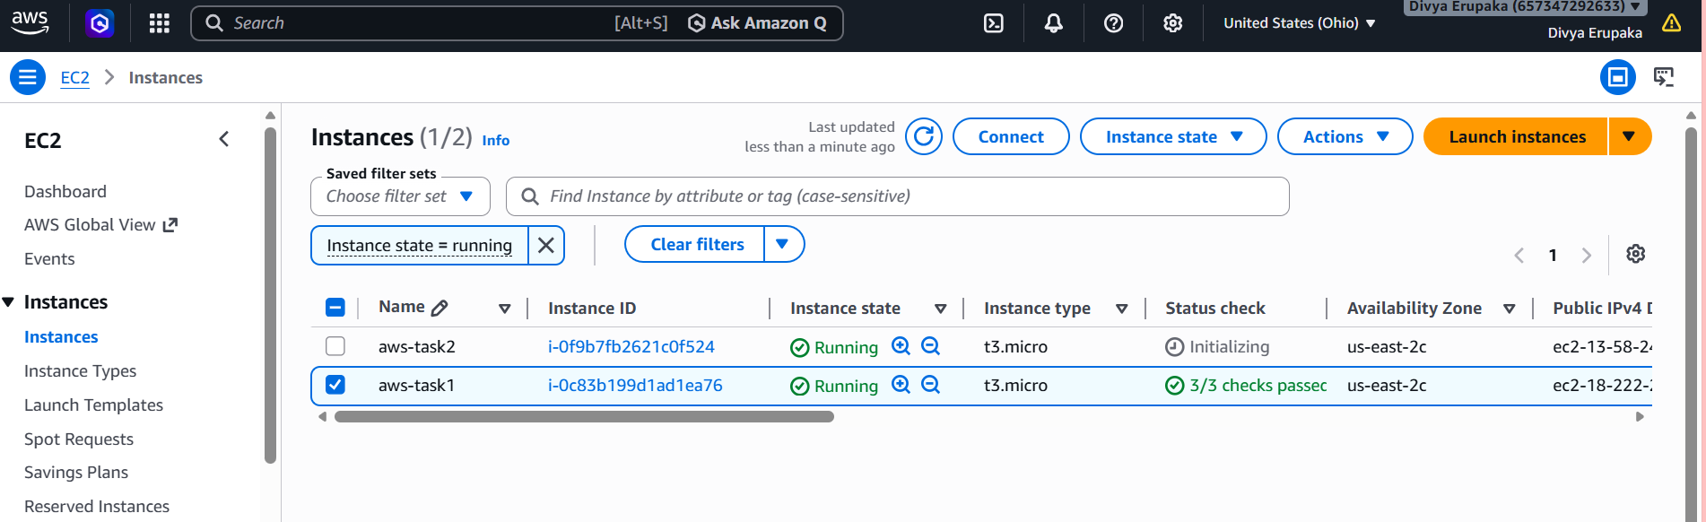
Login to instance using ssh -i command
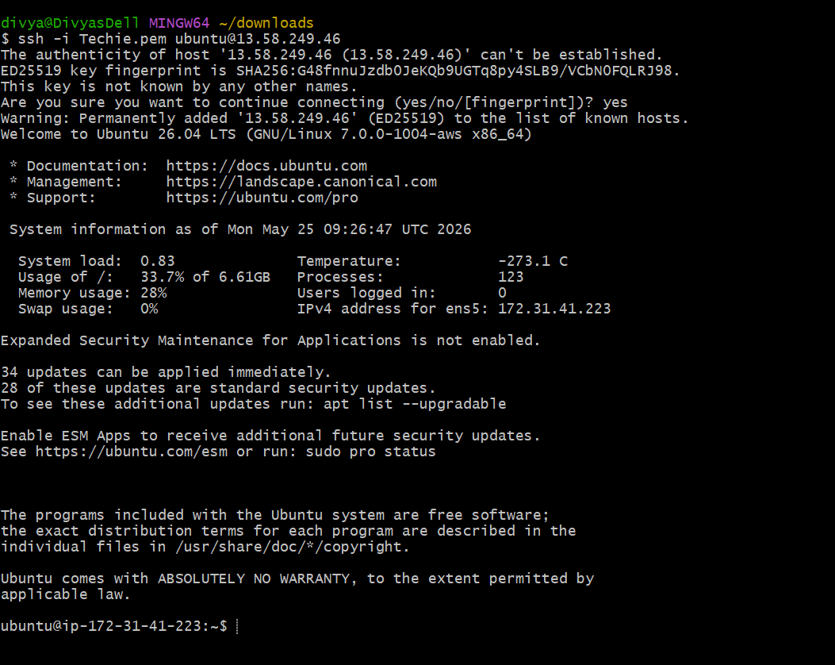
Check if service is running.
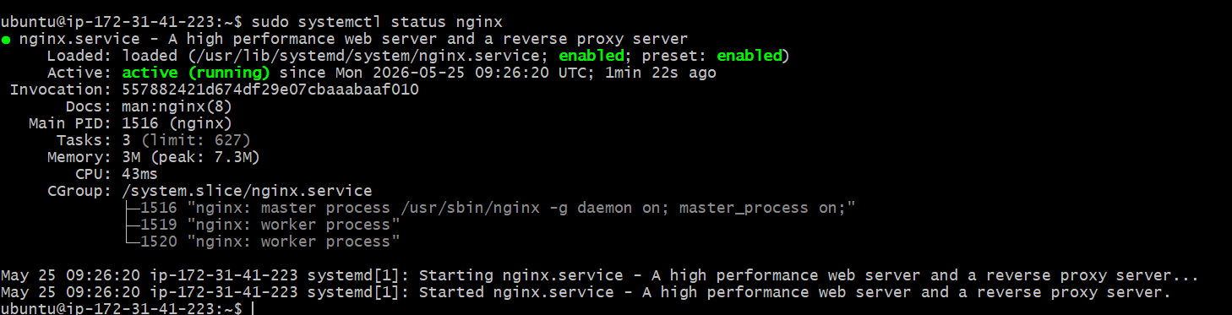
Access the Nginx Web Server
Procedure
Open browser and enter:
http://<PUBLIC-IP>:80
Expected Output:
Nginx Installed Successfully on Ubuntu EC2
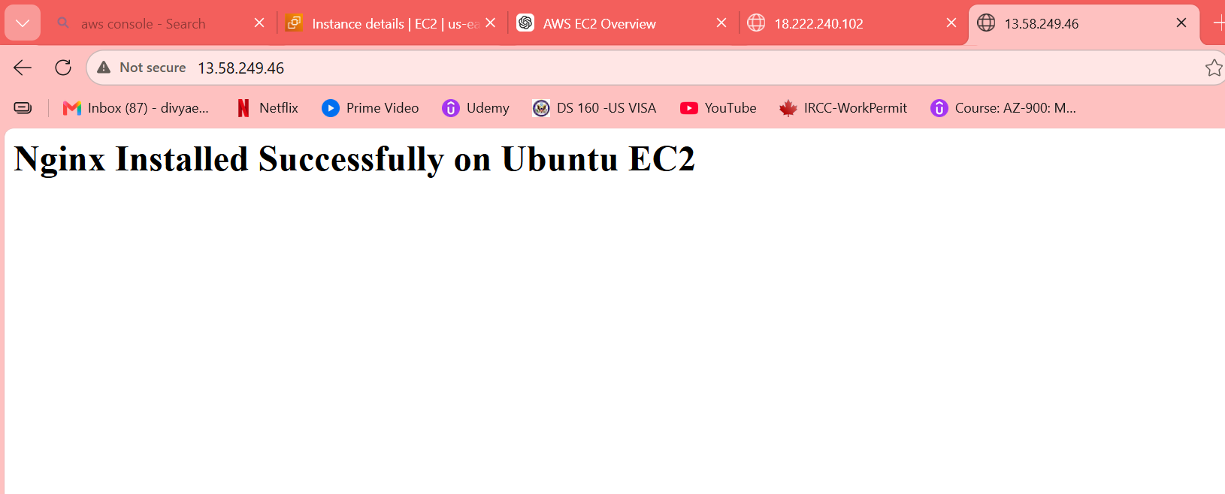
3. Launch one Windows server and install Tomcat on Windows
Objective: Launch a Windows EC2 instance in AWS and install Apache Tomcat on the server.
Step 1: Login to AWS Console
Open:
- AWS Console
Go to:
Services → EC2
Step 2: Launch Windows EC2 Instance
Click:
Launch Instance
Step 3: Configure EC2 Instance
Name
Example:
Windows-Tomcat-Server
Select AMI
Choose:
Microsoft Windows Server 2022 Base
Instance Type
Choose:
t3.micro
Key Pair
Select existing key pair or create new one.
Example:
Task.pem
Step 4: Configure Security Group
Allow these inbound rules:
Type | Port
RDP | 3389
HTTP | 80
Custom TCP | 8080
Why Port 8080?
Tomcat runs on:
http://Public-IP:8080

Step 5: Launch Instance
Click:
Launch Instance
Wait until:
- Instance State = Running
- Status Checks = 2/2 passed

Step 6: Connect to Windows Server
Select instance → Click:
Connect
Choose:
RDP Client
Download RDP file.
Step 7: Get Administrator Password
Click:
Get Password
Upload:
Task.pem
Decrypt password.

Step 8: Login to Windows Server
Use:
- Username:
Administrator
- Password:
(decrypted password)
Step 9: Install Java
Tomcat requires Java.
Download Java
Open browser in Windows server.
Download:
- Oracle Java Downloads
OR
- Eclipse Temurin JDK
Install:
Java 21

Step 10: Configure JAVA_HOME
Open:
System Properties → Advanced → Environment Variables
Create:
Variable | Value
JAVA_HOME | C:\Program Files\Java\jdk-21
Edit Path variable and add:
%JAVA_HOME%\bin

Step 11: Verify Java
Open Command Prompt:
java --version
Expected output:
java 21
Step 12: Download Apache Tomcat
Open browser.
Download:
- Apache Tomcat Downloads
Download:
Tomcat 10.1 Windows zip
Step 13: Extract Tomcat
Extract to:
C:\Tomcat
Step 14: Start Tomcat
Go to:
C:\Tomcat\bin
Double-click:
startup.bat
OR use CMD:
startup.bat
Step 15: Verify Tomcat
Open browser:
http://localhost:8080

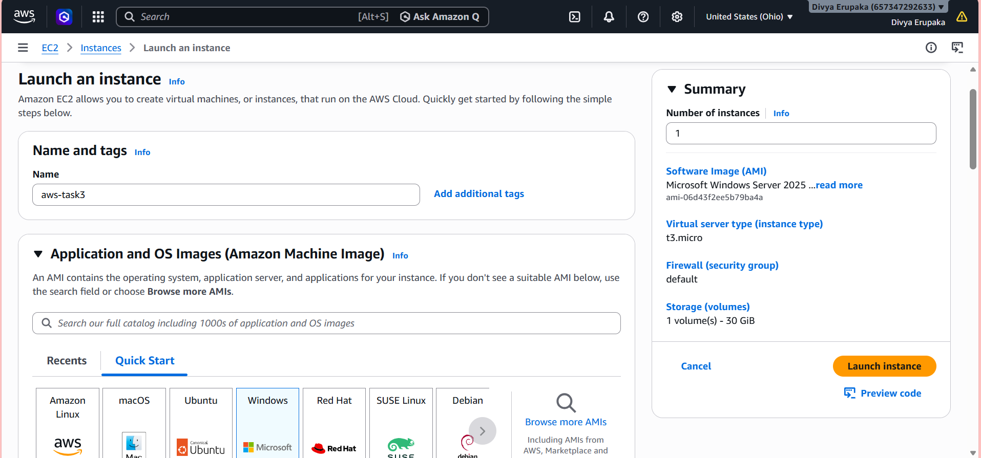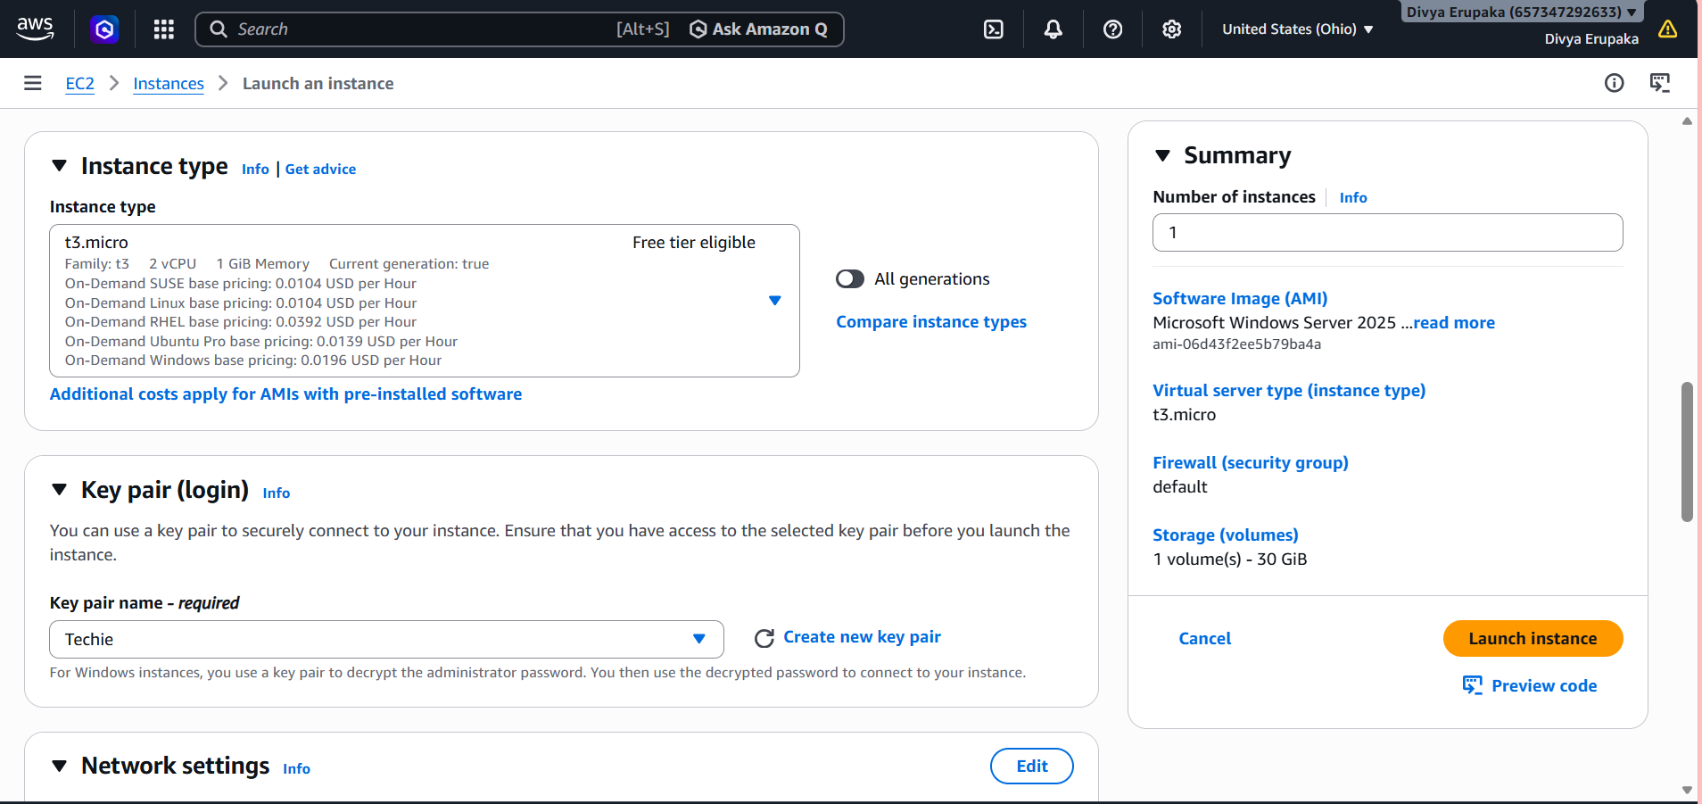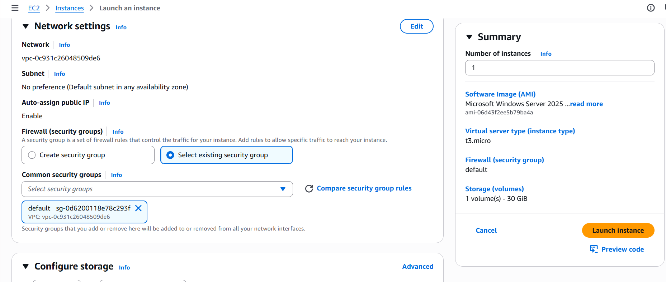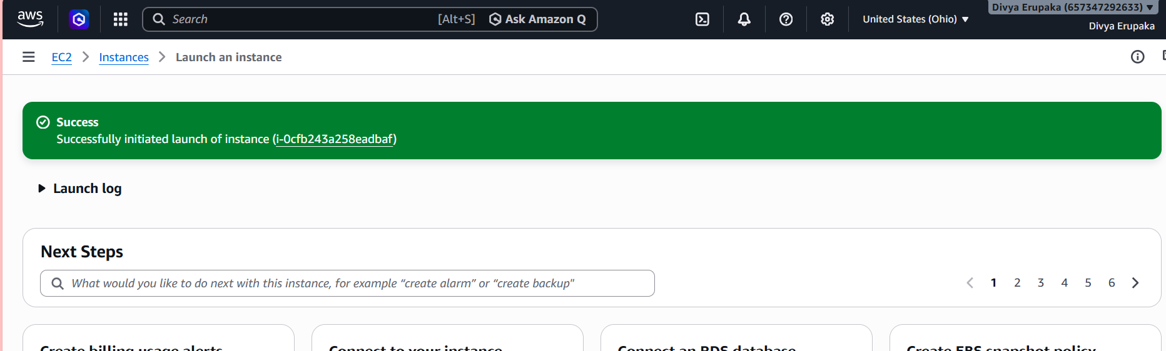
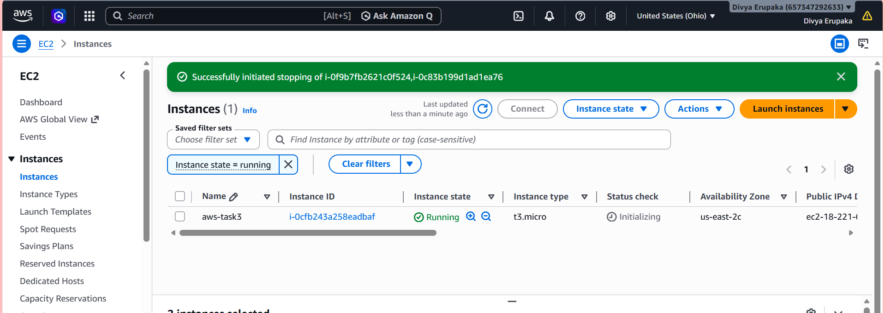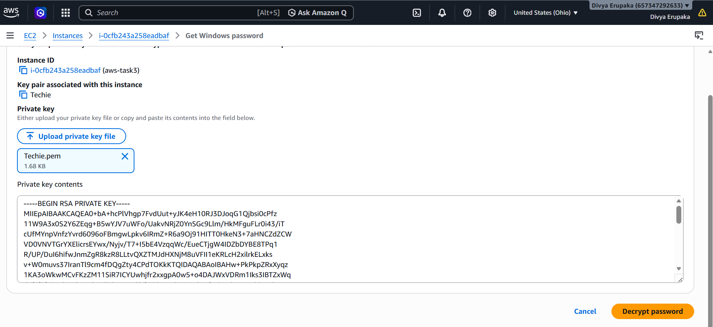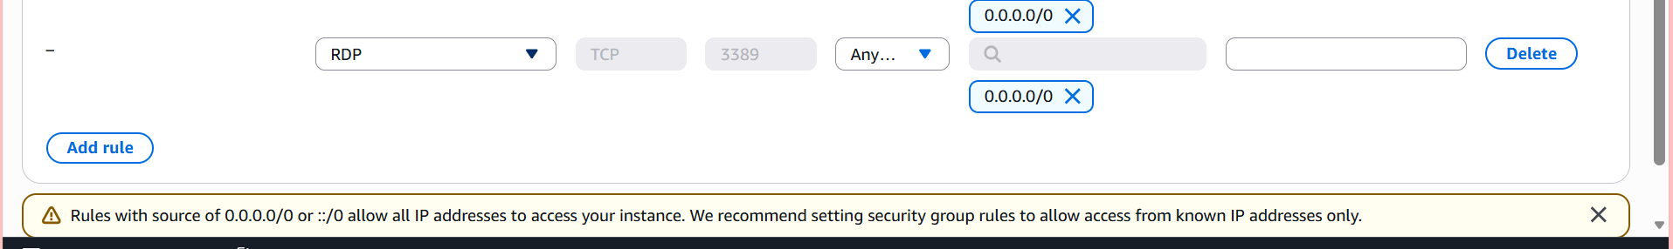
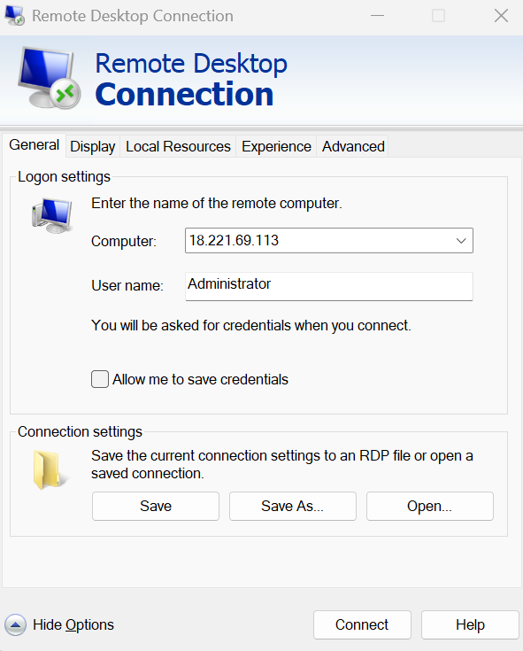
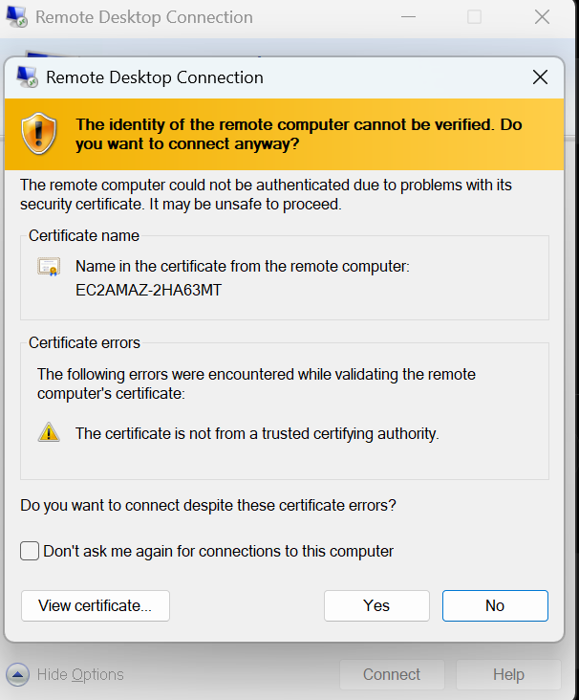
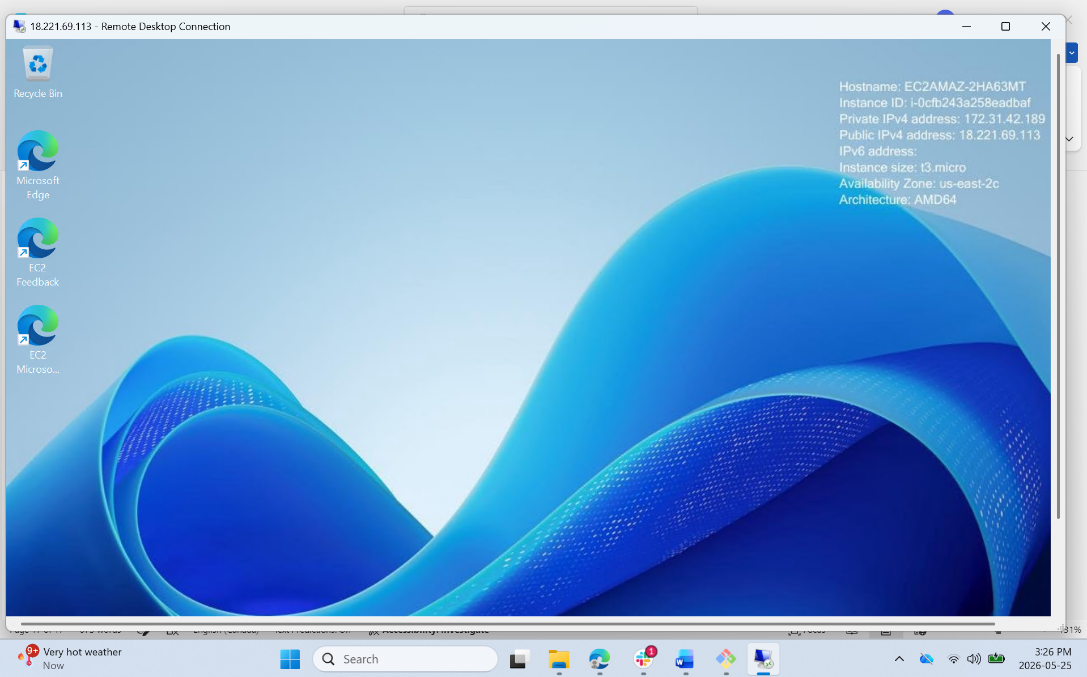
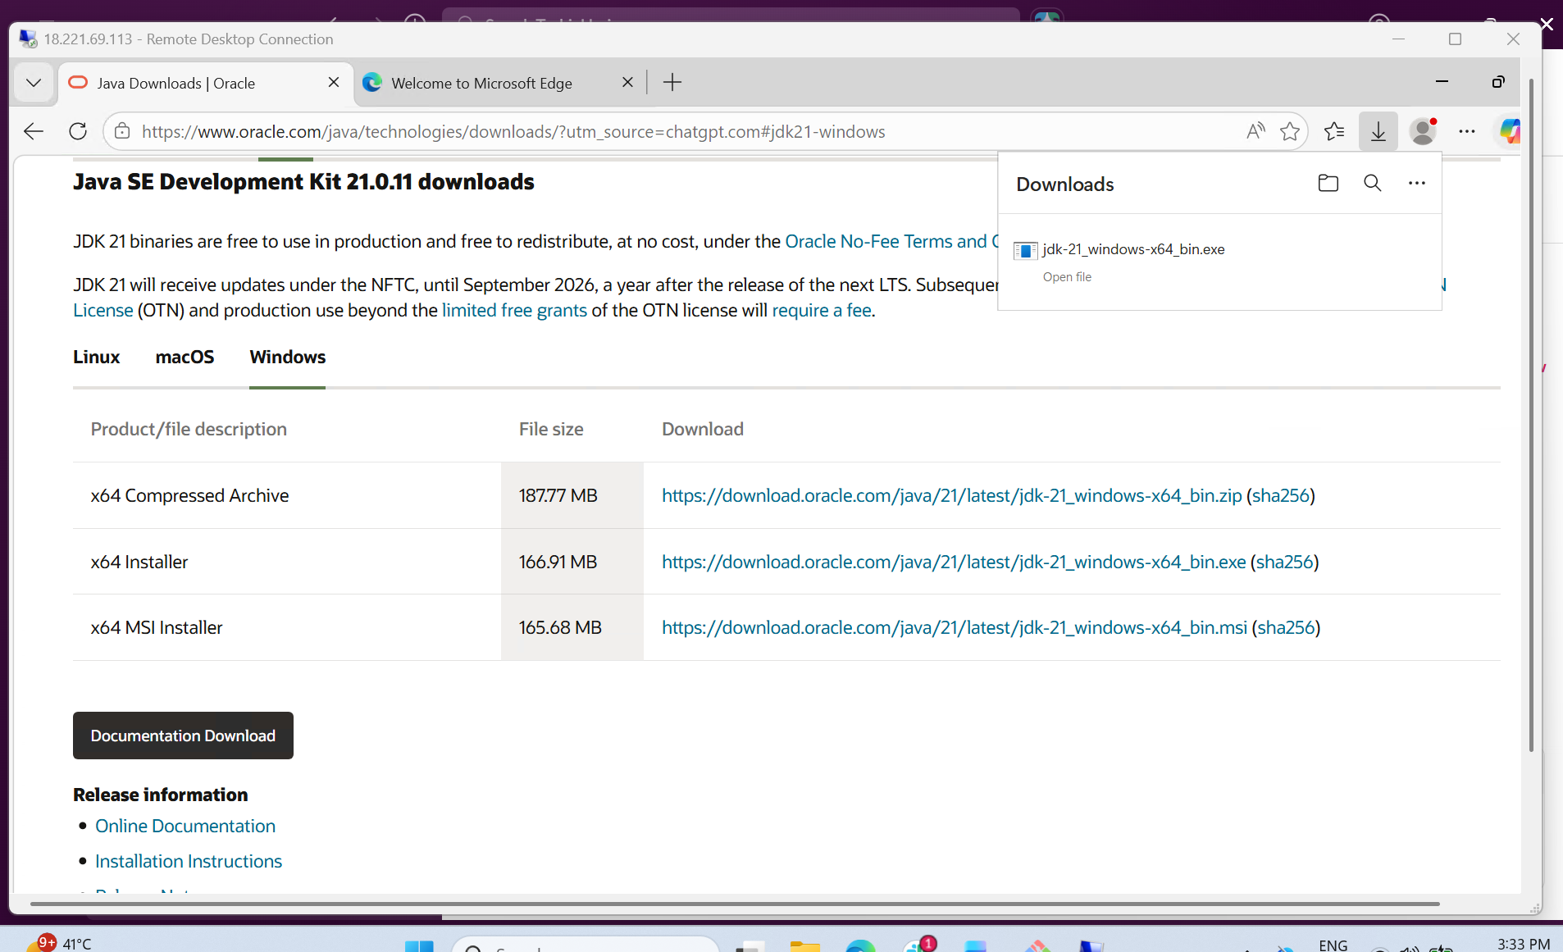
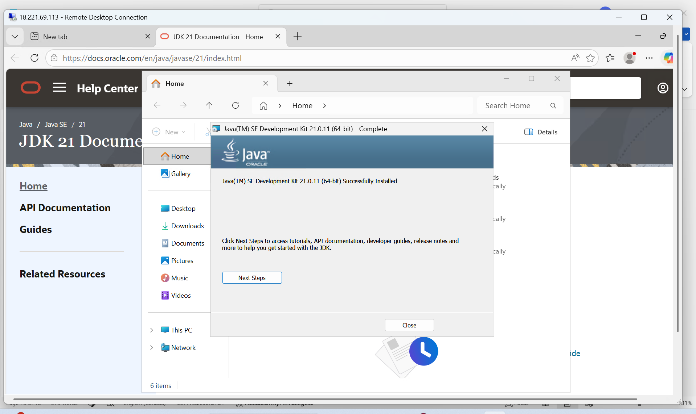
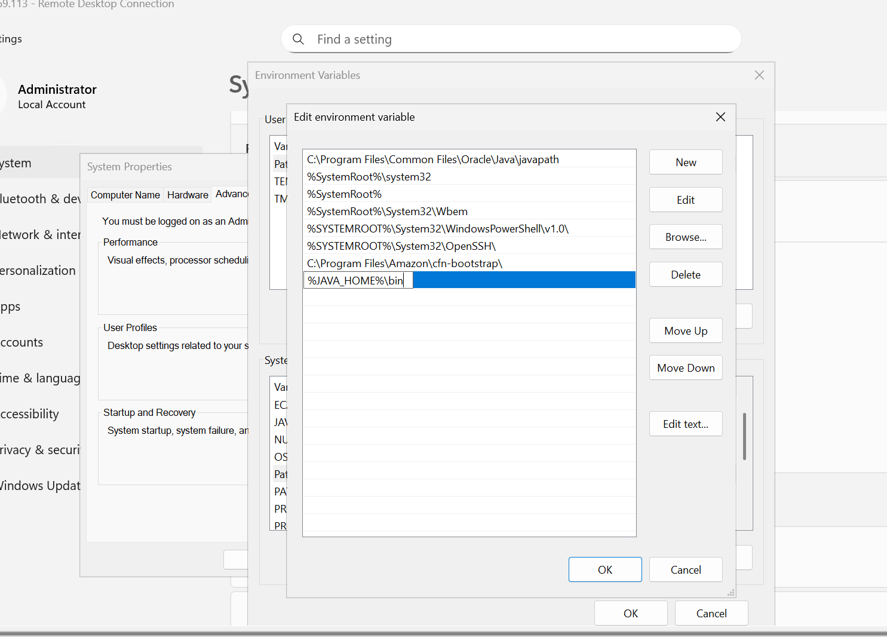
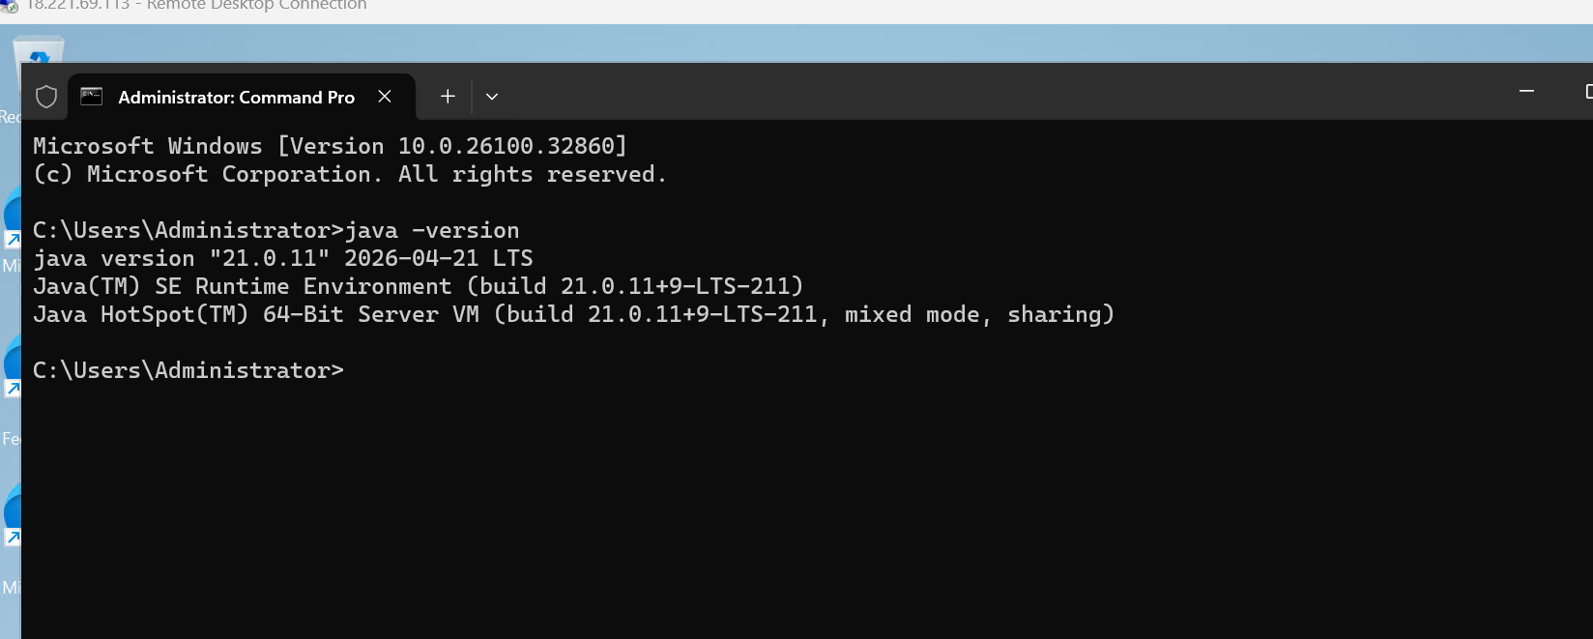
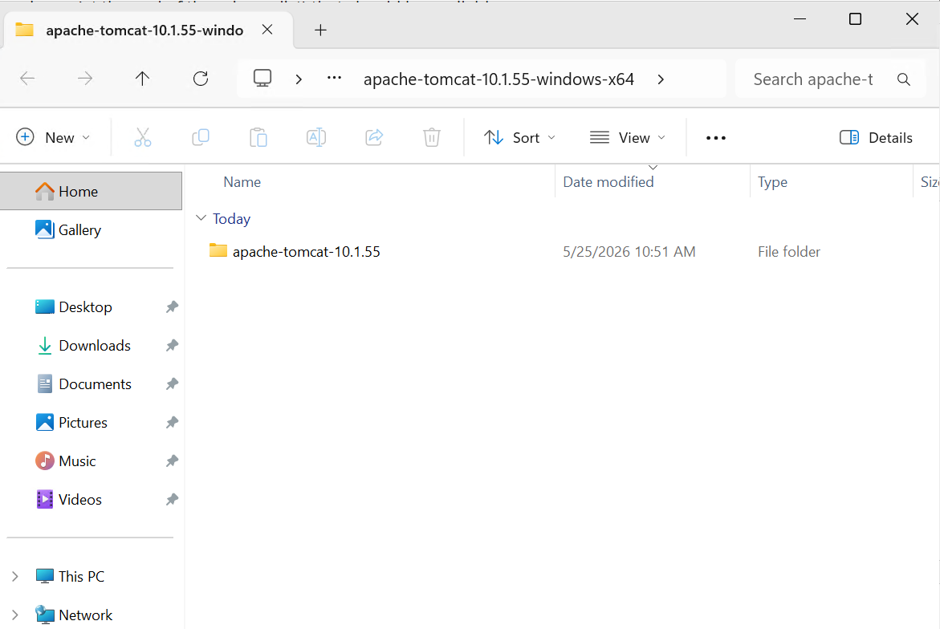
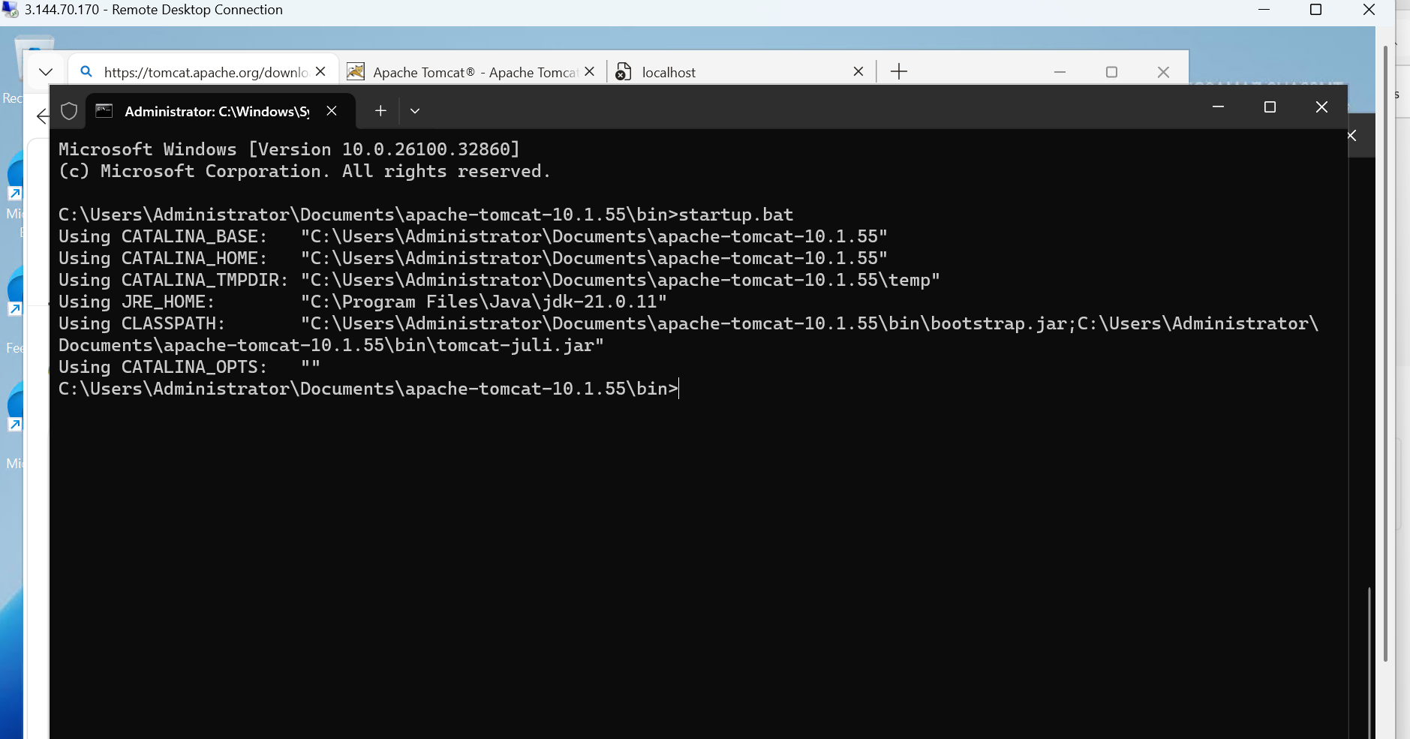
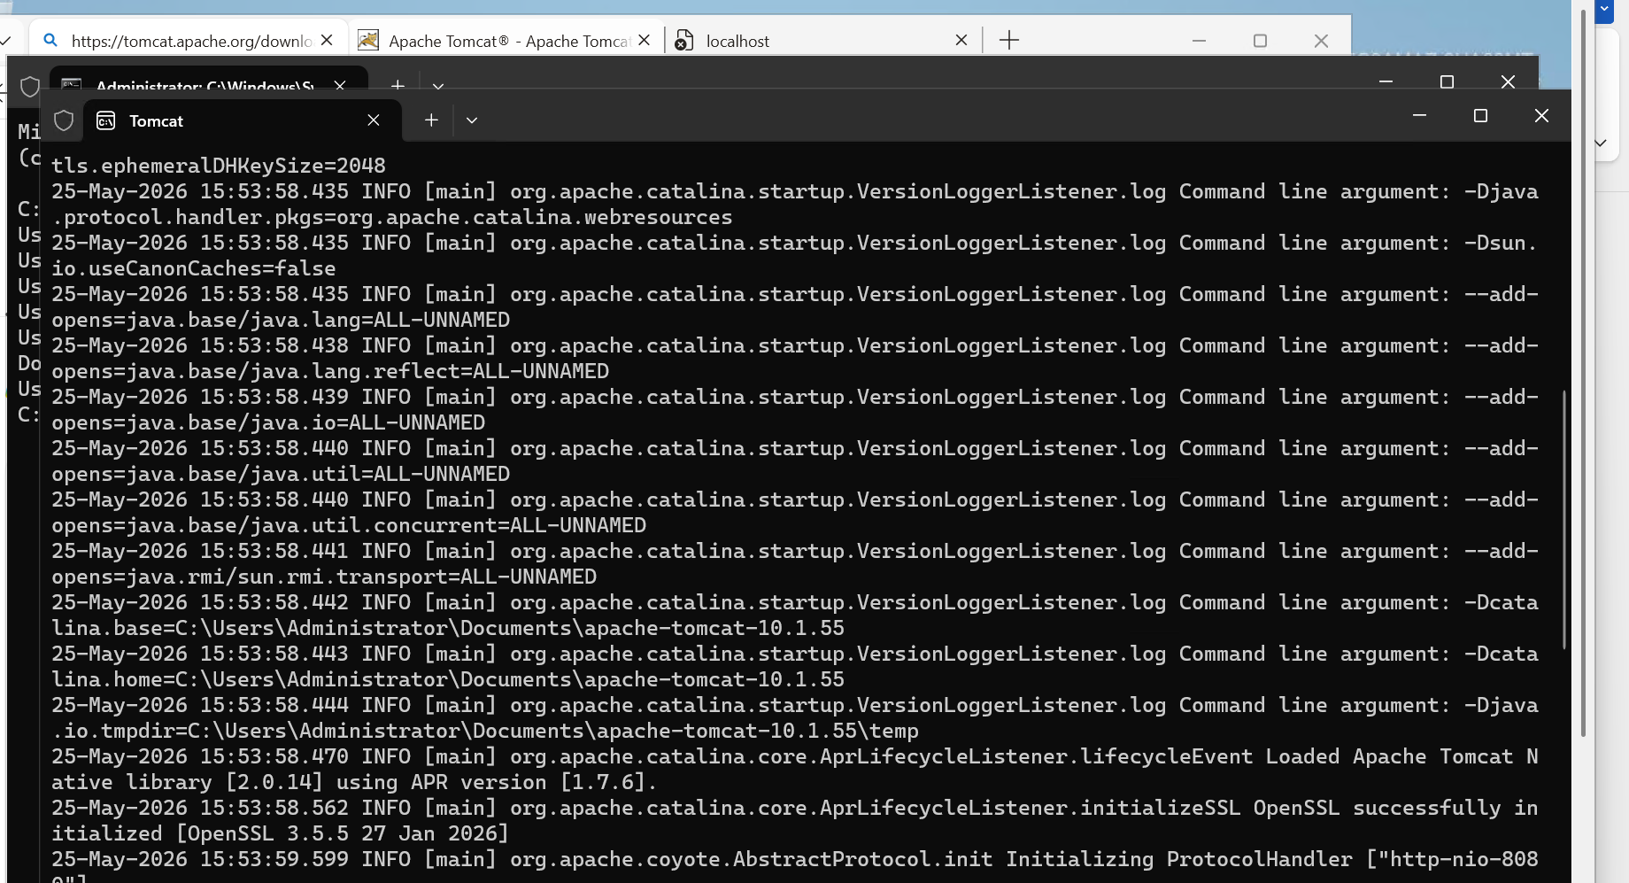
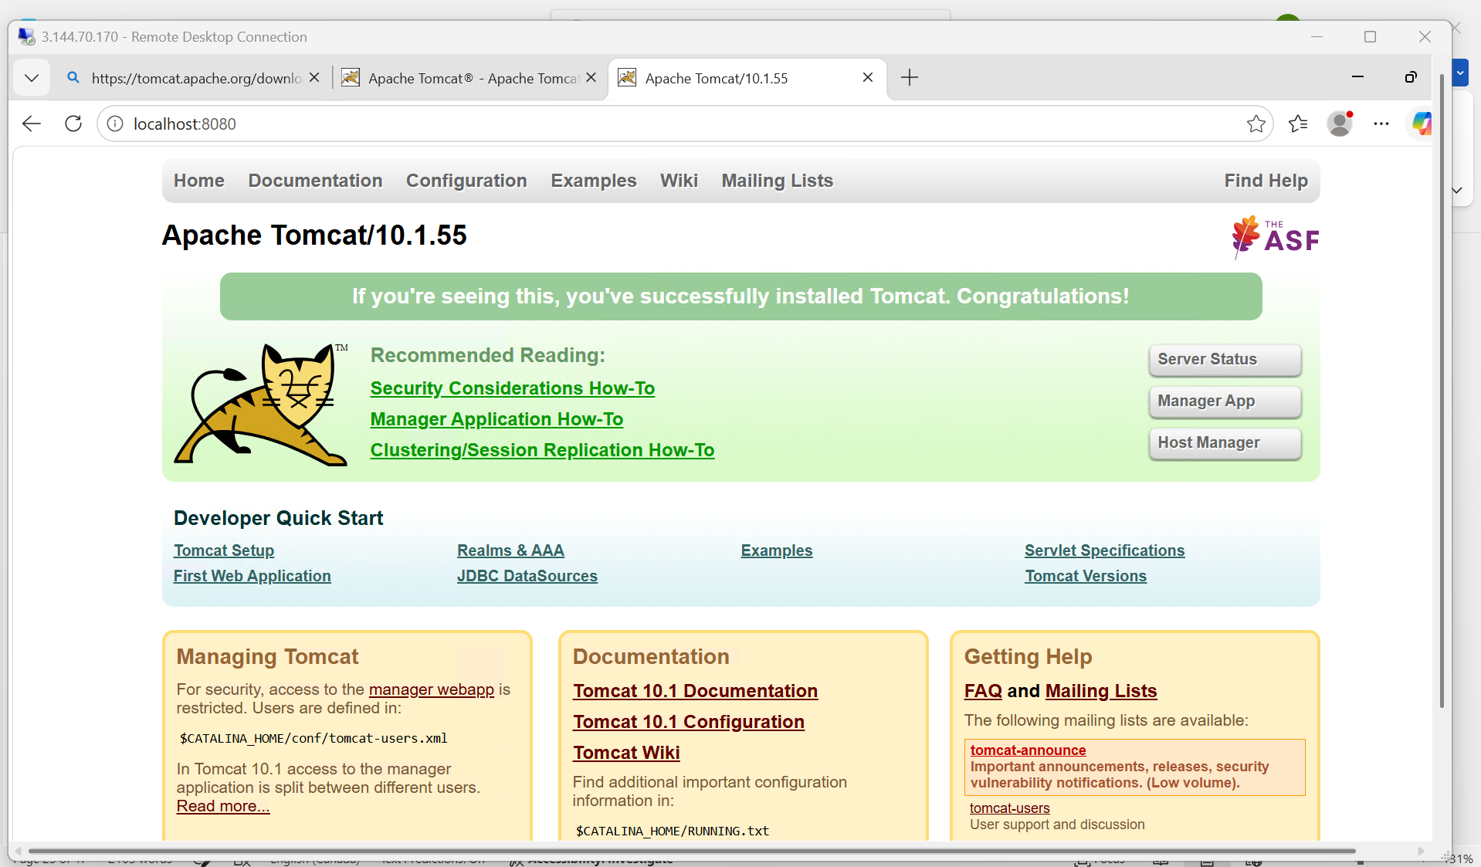
4. Take a snapshot of the instance created in Task 1

Objective: The objective of this task is to create a snapshot (backup) of the EBS volume attached to the Apache EC2 instance. The snapshot can later be used for:
- Backup and recovery
- Creating new volumes
- Creating AMIs
- Disaster recovery
Prerequisites
Before starting ensure:
- AWS account is available
- Apache EC2 instance is already created
- EC2 instance is in running state
Architecture Overview
Apache EC2 Instance
↓
EBS Volume
↓
Snapshot
Step 1: Login to AWS Console
Procedure
- Open AWS Management Console.
- Login using AWS credentials.
- Navigate to EC2 Dashboard.
AWS Console:
- AWS Management Console
Step 2: Open EC2 Instances
Procedure
Navigate to:
EC2 → Instances
Locate the Apache EC2 instance.
Example:
Apache-Web-Server
Verify:
- Instance State = Running
Step 3: Open Storage Tab
Procedure
- Select the EC2 instance.
- Scroll down to instance details.
- Open:
Storage Tab
You will see:
- EBS Volume ID
Example:
vol-xxxxxxxx
Add screenshot showing:
- Storage tab
- Attached EBS volume
Step 4: Open EBS Volume
Procedure
Click the Volume ID.
This opens:
Elastic Block Store → Volumes
Step 5: Create Snapshot
Procedure
- Select the EBS volume.
- Click:
Actions → Create Snapshot
Step 6: Configure Snapshot Details
Procedure
Enter snapshot details.
Snapshot Name
Example:
Apache-Server-Snapshot
Description
Example:
Backup snapshot of Apache EC2 instance
Step 7: Create Snapshot
Procedure
Click:
Create Snapshot
AWS starts creating the snapshot.
Step 8: Verify Snapshot
Procedure
Navigate to:
EC2 → Snapshots
Verify:
- Snapshot ID generated
- Status displayed
Initially:
Pending
After completion:
Completed
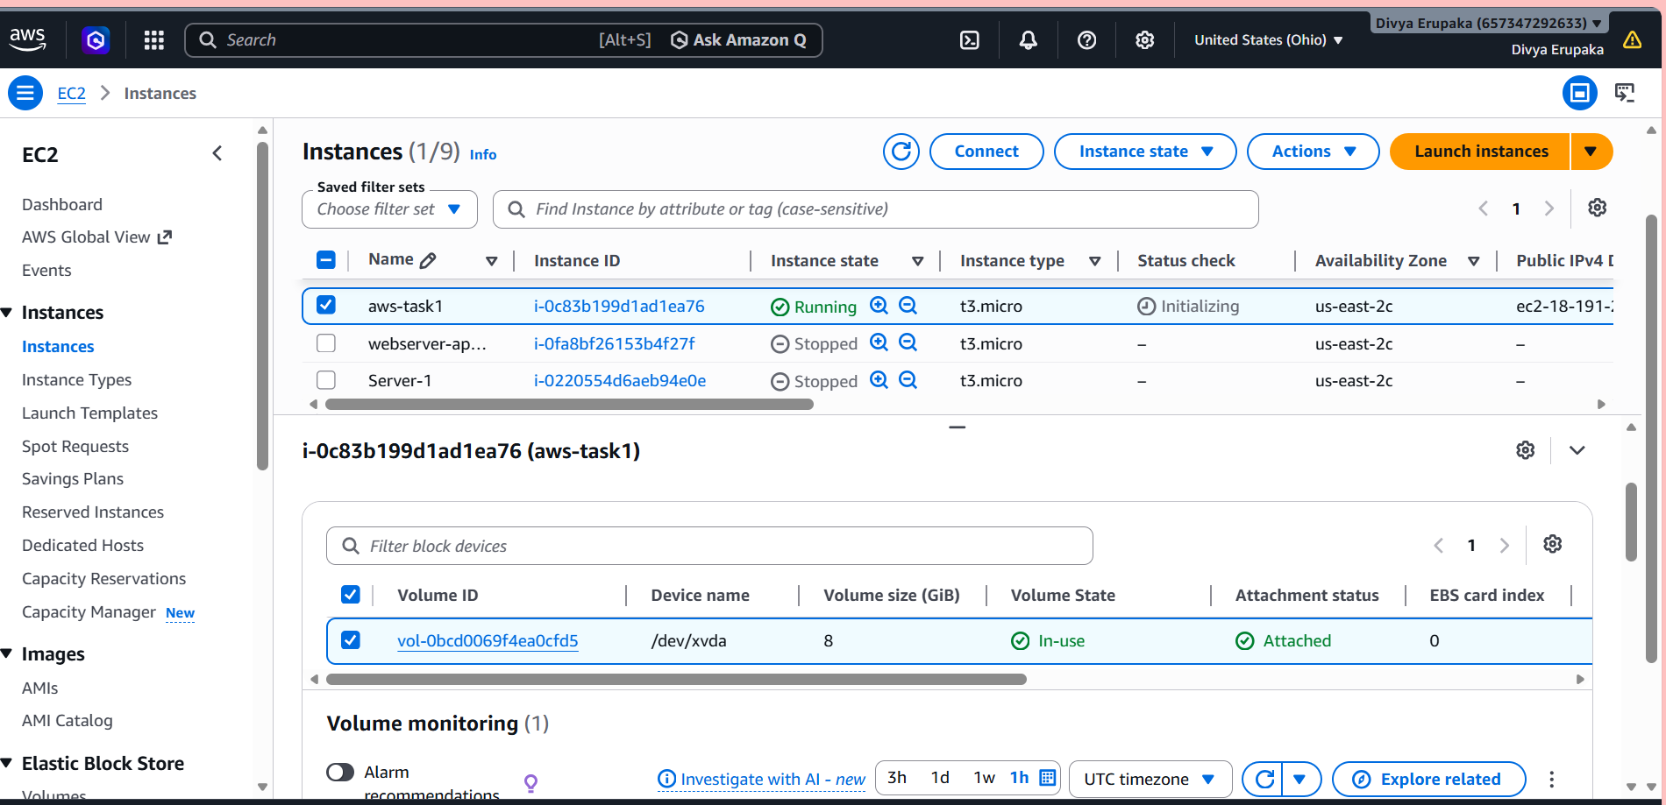
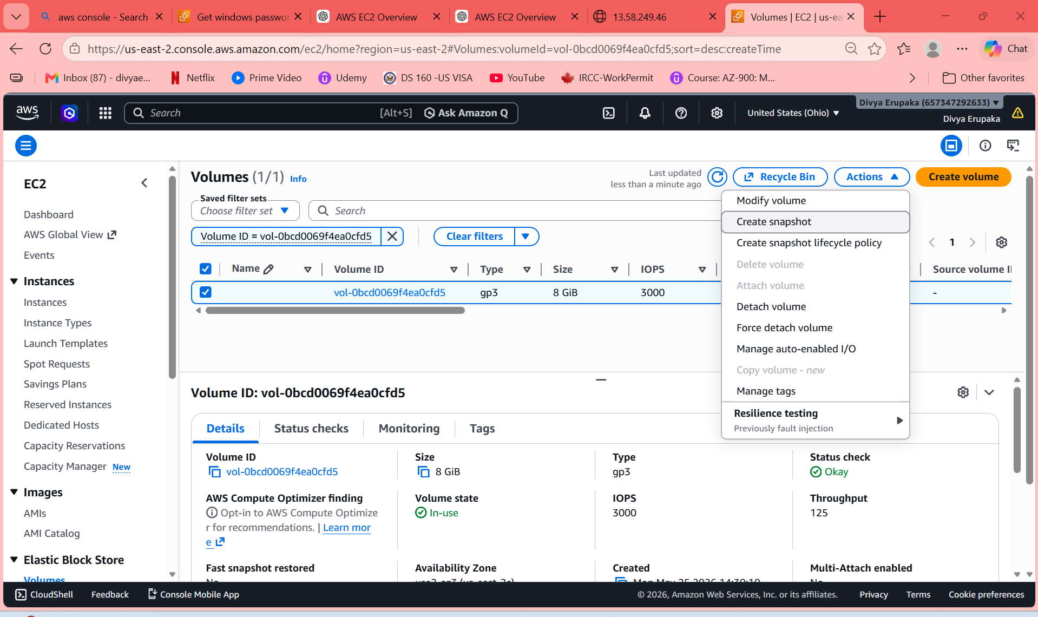
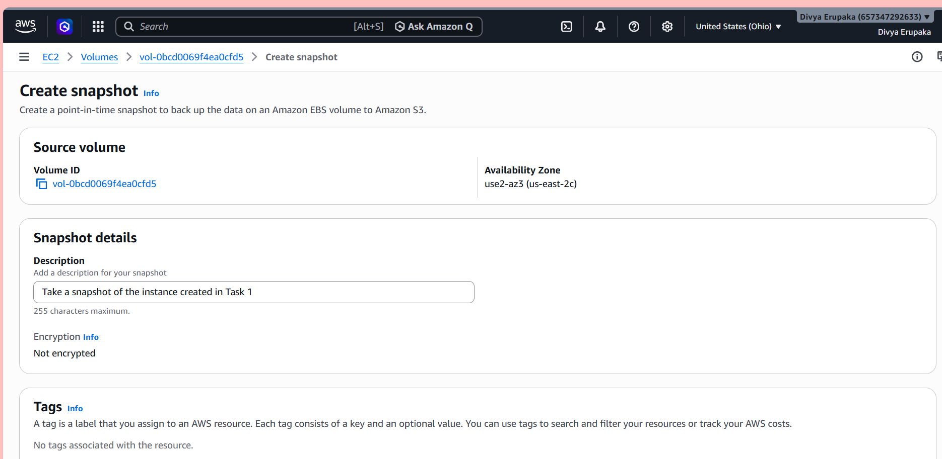
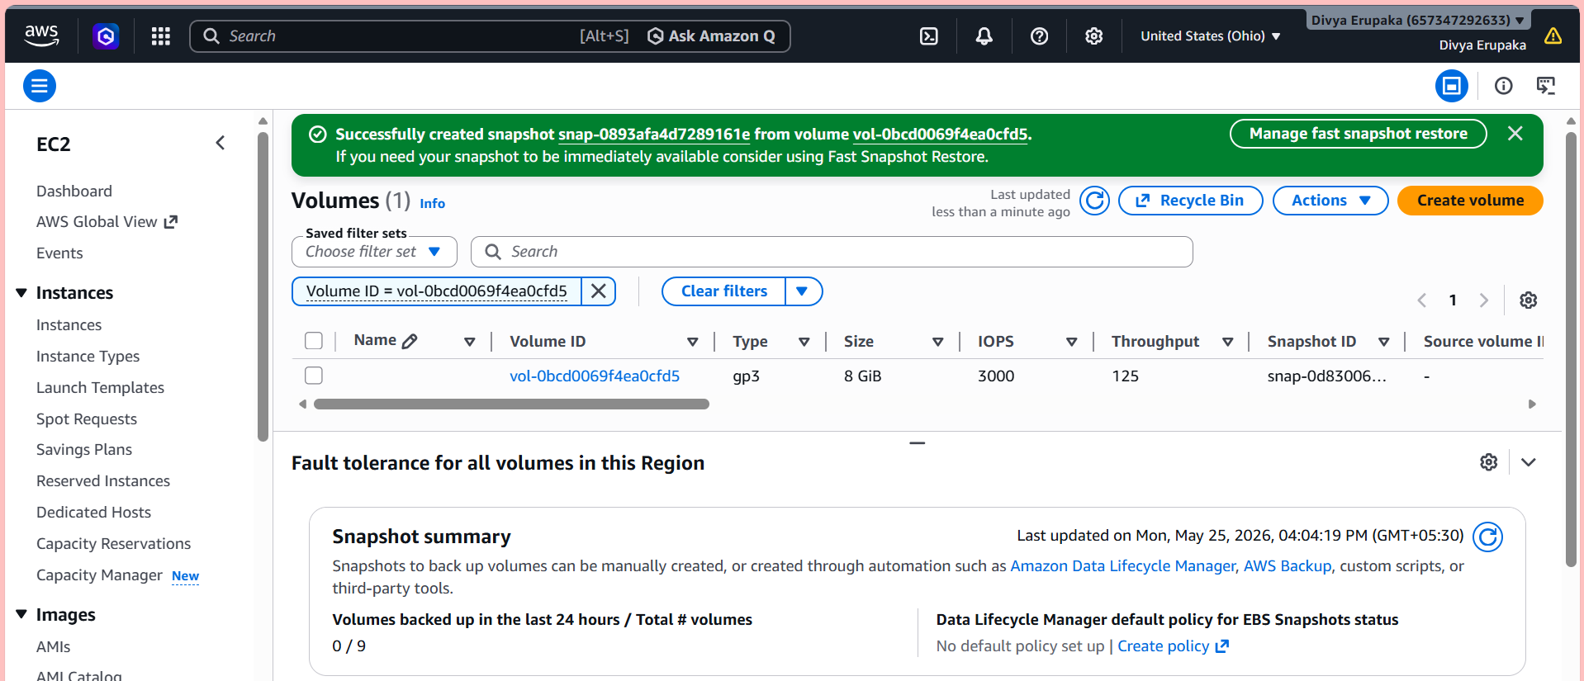
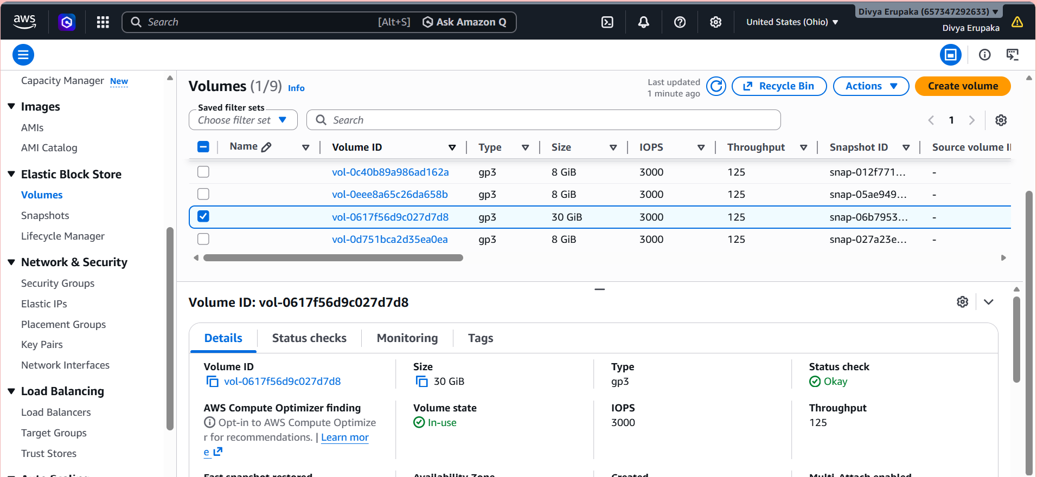
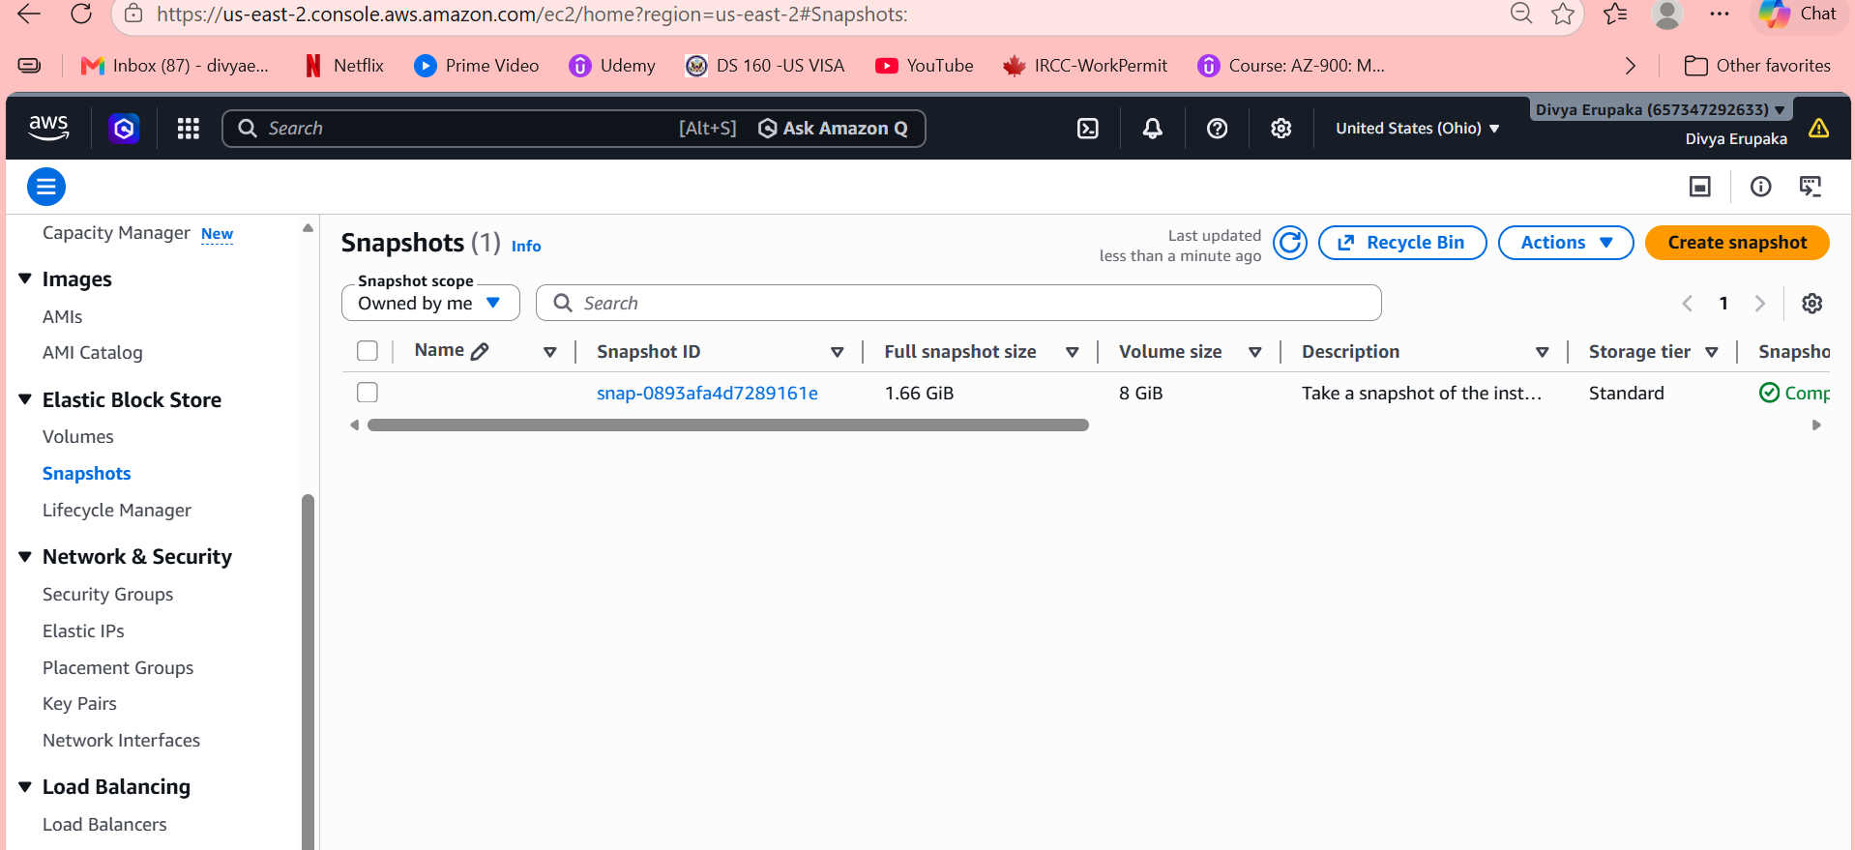
5. Assign passwordless authentication for the EC2 created in Task 2
Step 1: Login to Amazon Linux Server
From local machine:
ssh -i Techie.pem ec2-user@<AMAZON-LINUX-IP>
Step 2: Generate SSH Key Pair
On Amazon Linux run:
ssh-keygen
Press Enter for all prompts.
This creates:
~/.ssh/id_rsa
~/.ssh/id_rsa.pub
Step 3: Display Public Key
Run:
cat ~/.ssh/id_rsa.pub
Copy the ENTIRE output.
Example:
ssh-rsa AAAAB3NzaC1yc2EAAAADAQABAAAB...
Step 4: Login to Ubuntu Server
From your LOCAL machine:
ssh -i labsuser.pem ubuntu@<UBUNTU-IP>
Example:
ssh -i labsuser.pem ubuntu@18.xx.xx.xx
Step 5: Create .ssh Directory on Ubuntu
Inside Ubuntu server:
mkdir -p ~/.ssh
chmod 700 ~/.ssh
Step 6: Add Public Key
Open authorized_keys:
vi ~/.ssh/authorized_keys
Press:
i
Paste copied public key.
Save:
- Press Esc
- Type:
:wq
Press Enter.
Step 7: Set Correct Permissions
Run:
chmod 600 ~/.ssh/authorized_keys
Step 8: Exit Ubuntu Server
Run:
exit

Step 9: Test Passwordless Authentication
Now return to Amazon Linux server.
Run:
ssh ubuntu@<UBUNTU-IP>
Example:
ssh ubuntu@18.xx.xx.xx
Expected:
- Login successful
- No password
- No PEM key required

Reverse Configuration (Optional)
If you also want:
Ubuntu → Amazon Linux
Repeat same steps:
- Generate key on Ubuntu
- Copy public key to Amazon Linux

Security Group Requirements
Both servers must allow:
Type | Port
SSH | 22

Verify Passwordless Authentication
Run:
ssh -v ubuntu@<UBUNTU-IP>
Expected:
Authentication succeeded (publickey)
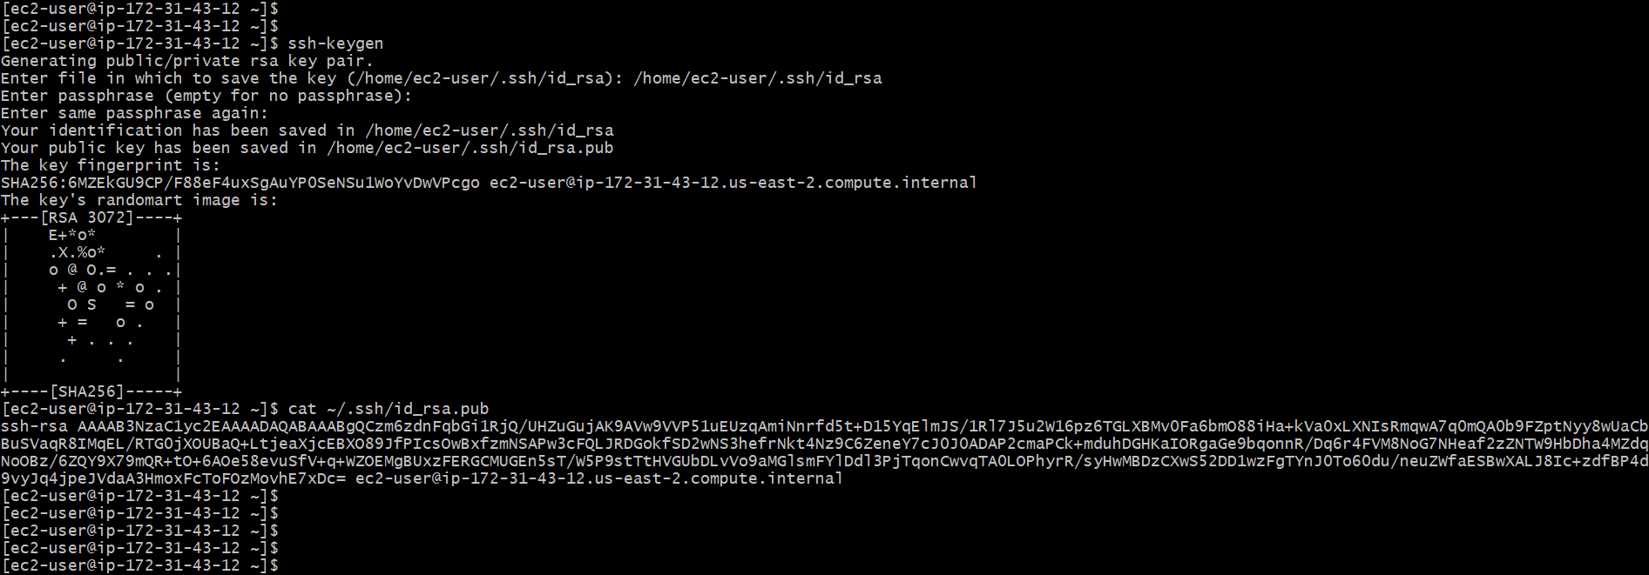
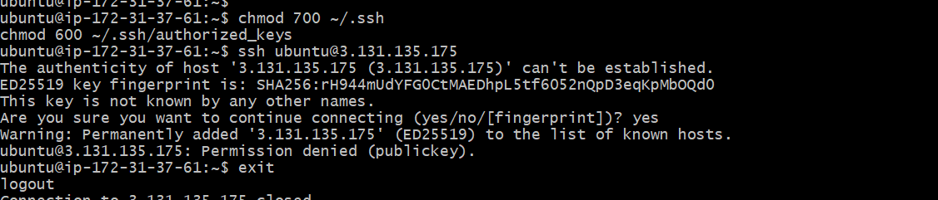
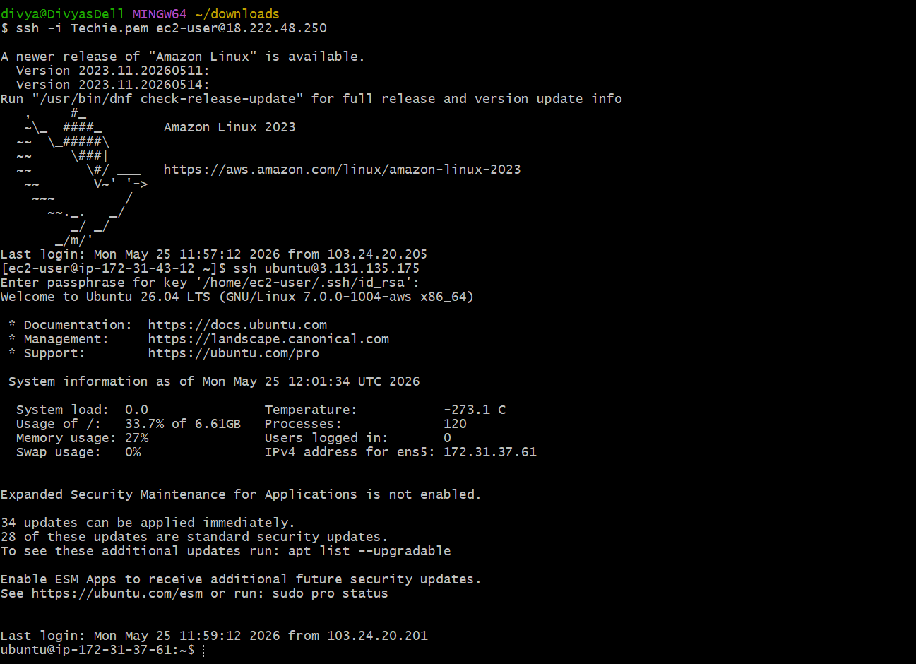
6. Launch any EC2 using the spot purchasing option
Objective: The objective of this task is to launch an AWS EC2 instance using the Spot purchasing option to reduce infrastructure cost.
Spot Instances allow you to use unused AWS EC2 capacity at significantly lower prices compared to On-Demand instances.
What is a Spot Instance?
A Spot Instance is:
- A low-cost EC2 instance
- Uses unused AWS capacity
- Can save up to 90% cost
- May be interrupted by AWS when capacity is needed
Advantages of Spot Instances
- Very low cost
- Ideal for:
  - Testing
  - Batch jobs
  - CI/CD
  - Development
  - Temporary workloads
Important Note
Spot instances:
- Can be terminated anytime by AWS
- Are NOT recommended for critical production workloads unless interruption handling is configured
Step 1: Login to AWS Console
Open:
- AWS Management Console
Navigate to:
EC2 Dashboard

Step 2: Launch Instance
Click:
Launch Instance

Step 3: Configure Instance Name
Example:
Spot-Instance-Server

Step 4: Select AMI
Choose any Linux AMI.
Recommended:
Amazon Linux 2
OR
Ubuntu Server 22.04

Step 5: Choose Instance Type
Example:
t2.micro
OR
t3.micro

Step 6: Configure Key Pair
Select existing key pair.
Example:
labsuser.pem

Step 7: Configure Network Settings
Add Security Group rules:
Type | Port
SSH | 22
HTTP | 80
Source:
0.0.0.0/0

Step 8: Configure Spot Instance
This is the important step.
Scroll down to:
Advanced Details
Expand it.

Step 9: Enable Spot Instance Request
Find:
Request Spot Instances
Select:
Enable

Step 10: Configure Spot Options
Choose:
Request Type
One-time
OR
Persistent
Recommended:
One-time

Spot Instance Type
Leave default:
Capacity Optimized

Step 11: Launch Spot Instance
Click:
Launch Instance
AWS now attempts to allocate Spot capacity.

Step 12: Verify Spot Instance
Go to:
EC2 → Instances
You should see:
Lifecycle = Spot
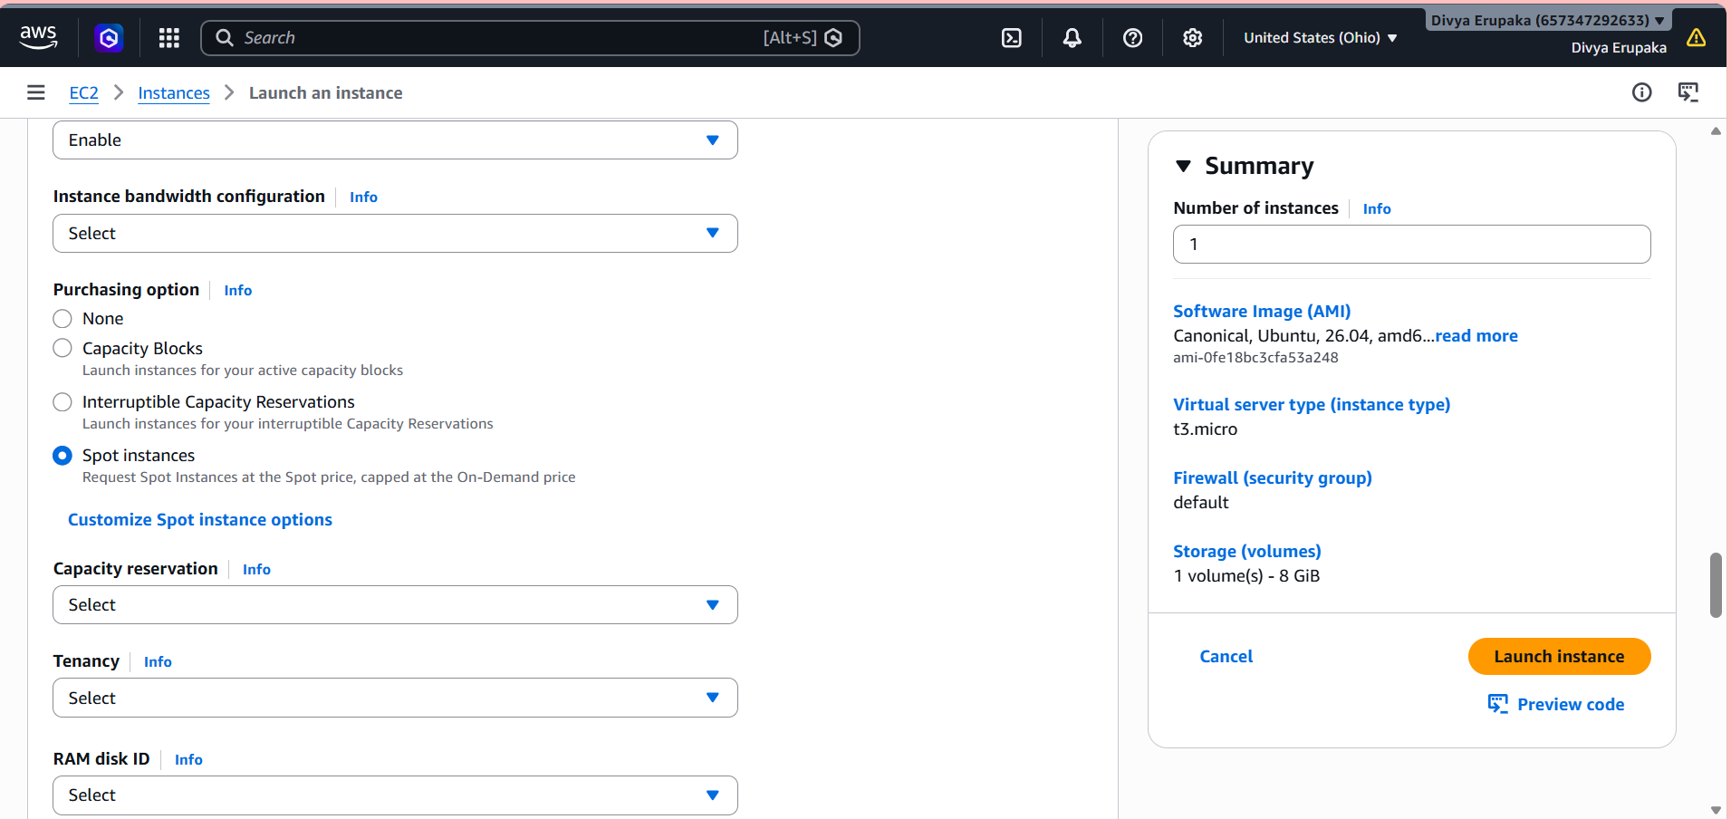
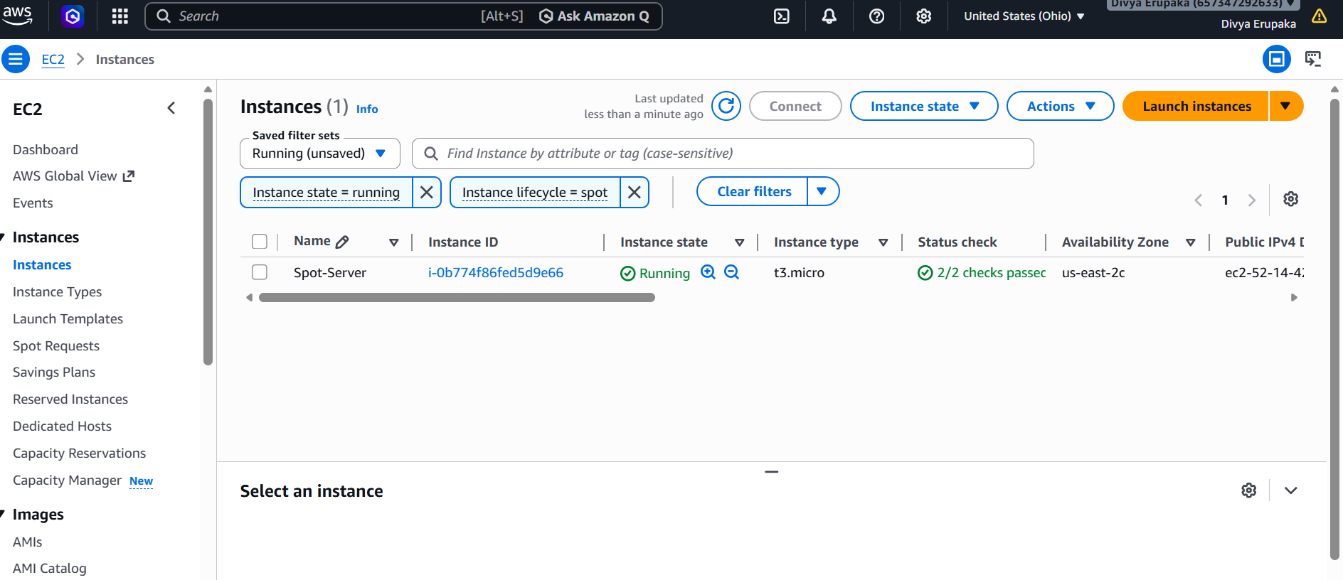
7. Enable termination policy on the EC2 created in Task 2.
Objective
The objective of this task is to enable Termination Protection on an EC2 instance.
Termination Protection prevents accidental deletion of an EC2 instance.

What is Termination Protection?
Termination Protection is an AWS EC2 feature that:
- Prevents accidental instance termination
- Adds safety for important servers
- Blocks deletion attempts until protection is disabled

Important Note
When enabled:
- Instance CANNOT be terminated normally
- AWS shows an error if termination is attempted
To terminate the instance later:
- You must first disable termination protection

Step 1: Open AWS EC2 Console
Go to:
- AWS EC2 Console
Navigate to:
EC2 Dashboard

Step 2: Open Instances Page
From left sidebar click:
Instances

Step 3: Select EC2 Instance
Select the EC2 instance created in Task 2.
Example:
- Ubuntu EC2
- Amazon Linux EC2
- Windows EC2

Step 4: Open Instance Settings
At top menu click:
Actions
→ Instance Settings

Step 5: Enable Termination Protection
Click:
Change Termination Protection
A popup opens.

Step 6: Enable Protection
Select:
Enable
Then click:
Save

Step 7: Verify Termination Protection
Select the instance.
Go to:
Details Tab
Look for:
Termination Protection
Expected:
Enabled
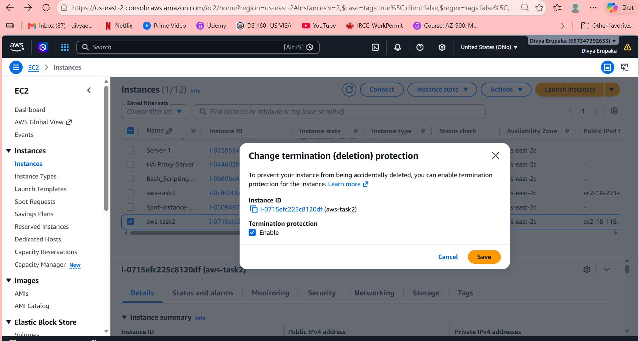
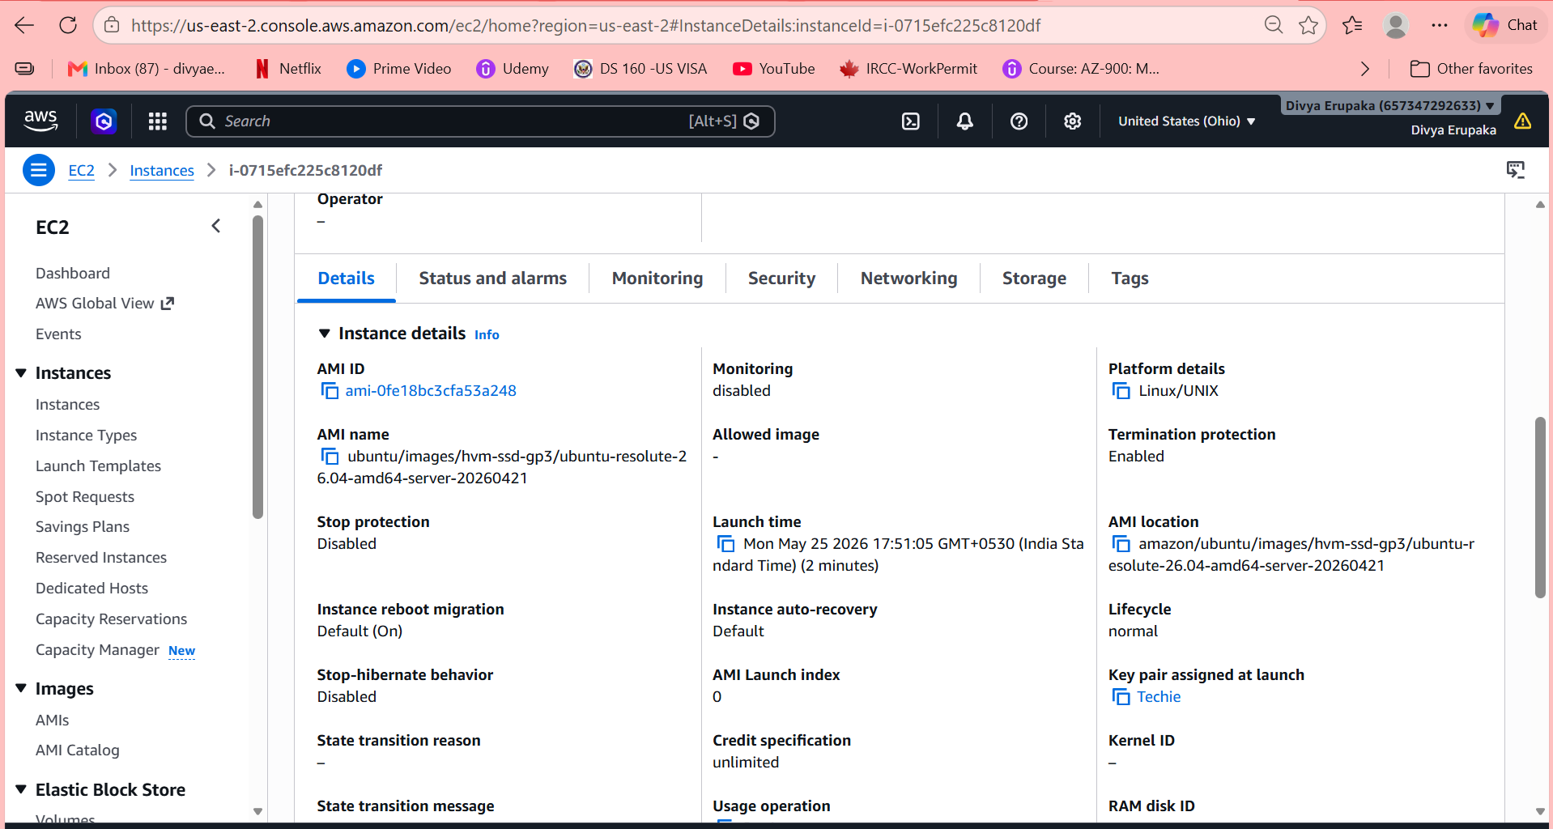
8. Launch one EC2 using AWS CLI
Objective: Launch an Amazon EC2 instance using AWS CLI.
Step 1: Configure AWS CLI
Command used:
aws configure
Configured:
- AWS Access Key
- AWS Secret Key
- Region: us-east-1
- Output format: json
Step 2: Verify AWS CLI Installation
Command:
aws --version
Output confirmed AWS CLI installation.
Step 3: Find Amazon Linux 2 AMI
Command:
aws ec2 describe-images \
--owners amazon \
--filters "Name=name,Values=amzn2-ami-hvm-*" \
--query 'Images[*].[ImageId,Name]' \
--output table
Selected AMI:
ami-006e2b873bfe6aa1
Step 4: Verify Available Key Pairs
Command:
aws ec2 describe-key-pairs --output table
Selected key pair:
Task
Step 5: Verify Subnets
Command:
aws ec2 describe-subnets --output table
Selected subnet:
subnet-0bd326ae1a47aeffc
Availability Zone:
us-east-1b
Step 6: Verify Security Groups
Command:
aws ec2 describe-security-groups --output table
Selected Security Group:
sg-0e7f3b058d7821933
Step 7: Launch EC2 Instance
Final command used:
aws ec2 run-instances \
--image-id ami-006e2b873bfe6aa14 \
--count 1 \
--instance-type t3.micro \
--key-name Task \
--security-group-ids sg-0e7f3b058d7821933 \
--subnet-id subnet-0bd326ae1a47aeffc
Step 8: Verify EC2 Instance
Command:
aws ec2 describe-instances --output table
Verified:
- Instance state = running
- Instance type = t3.micro
- Platform = Linux/UNIX
Result
Successfully launched an EC2 instance using AWS CLI with:
- Amazon Linux 2 AMI
- t3.micro instance type
- Existing key pair
- Existing subnet and security group
AWS Console Verification
Open:
- AWS EC2 Console
Navigate:
EC2 → Instances
You will see:
- Running EC2 instance
- Instance ID i-04d783a07b5518360
